Visual Literacy Lesson Plan St Ambrose University IL101 – Herzig

ACRL Framework:
Information Creation as a Process
Research as Inquiry, Information has Value.

Making an Infographic from Census data
Time: a 60-70 minute one-session activity.
Websites needed: https://data.census.gov/cedsci/ and a free web-based infographic application; I use https://infogram.com/
I start with asking the students if they know how many people in their hometown zip code has a bachelor’s degree? Where would find that information? We discuss briefly, who gathers data like that. We then bring up the census website. (there are many ‘doors’ to the census and the one above gets one there fastest.)
The student enters their hometown zip code into the search box and enters. (I have found that if the hometown zip is too small – under 10,000 – it may not have the data needful, in which case they choose a larger close city or the city where the university/college is located)
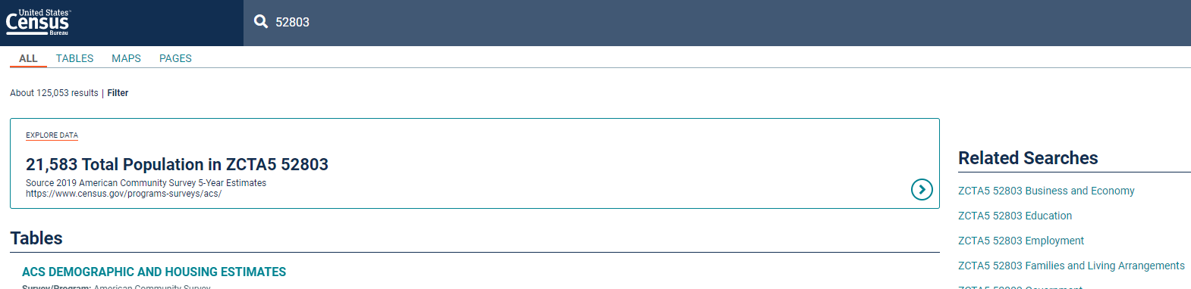
TIP: If the basic data of population does not appear, use a larger population zip code.
We note how many ways to look at their zip code there are, but we click on Education on the right side menu Then once there, click on ‘Educational Attainment’
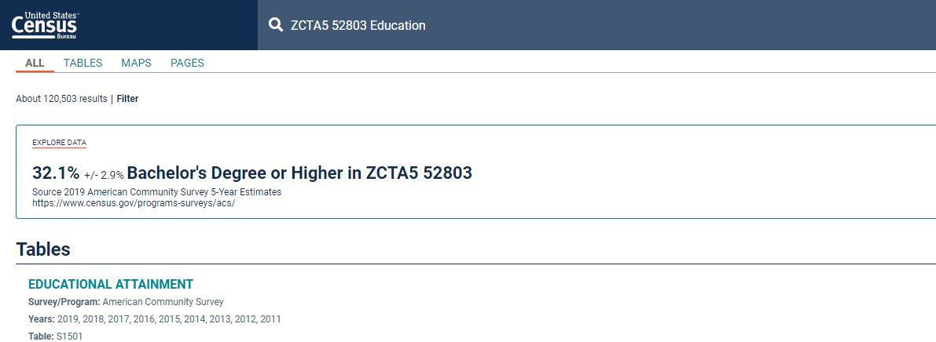
We pause to see how our original question is answered (here it is 32.1%).
Less than half sometimes amazes them.
This table for Educational Attainment includes levels of schooling/degrees, AND Wages earned by schooling level (at the bottom of the chart)
Tip: If there are XXX;s in the chart under wages, use a different year (at top of chart drop-down).
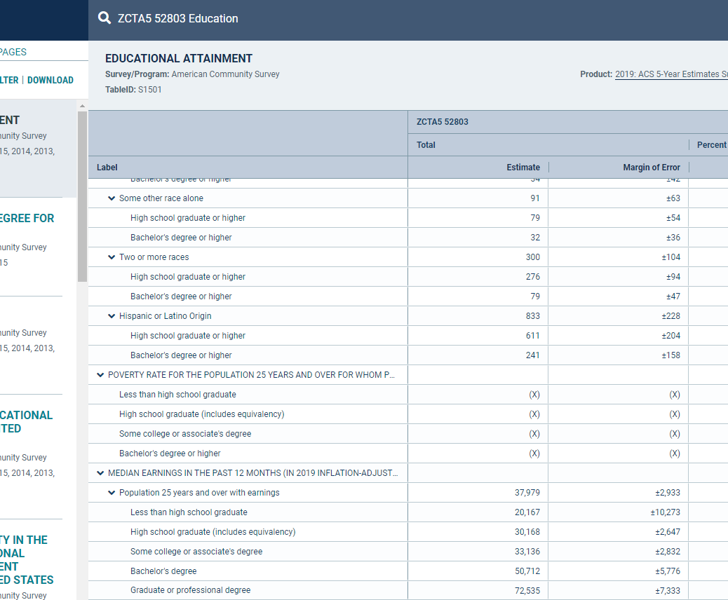
Here we all acknowledge that our eyes glaze over at this table full of numbers!
How can we present this visually so an audience can understand some facts around these numbers and what they illuminate about our world.
Here we open the second website Infogram in a new tab and then sign in to Infogram with Google (we use our university gmail account here at SAU)

Tip: After the student identifies themselves as students at a university, it often lands one on a promotion to pay for Infogram, if so, ask the students to erase all the browser URL UP TO the homepage of infogram and hit enter. This will place them into their account to access the template needed.
Then model the step-by-step process and have the students follow step-by-step.
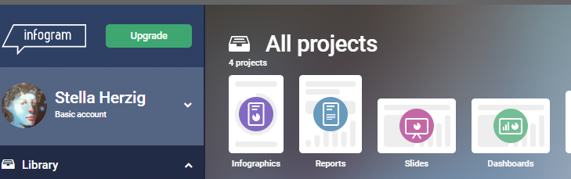
Open the Infographics and then choose a blank template.
It is important to name the project both as the project and on the blank template itself, using the ‘add TEXT’ in Infogram. I remind the students that I will try to model some best practice for labelling and choosing datasets.
I name the project Wages and Education in 52803 (the zip code you/they are using)
I then choose Add Chart, a grouped chart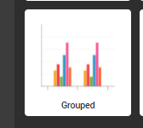
To allow for the differences between men and women.
In the edit controls, Erase the dummy data and in A2, place the labels for median wages, going from Less than 9th grade to Graduate. It is found at the bottom of the educational attainment table
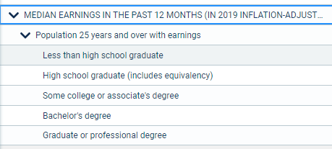
Copy and paste into the A2 of the infogram edit area.
Then:
In B1 add the word MALE and in C1 add the word FEMALE
Copy the data for MALE estimate column for those labels added in B2
NOT the total number, just the ones corresponding to Less than 9th grade to Graduate:
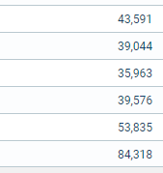

Do the same for the Female Estimate for wages in C1
The chart should look like this:
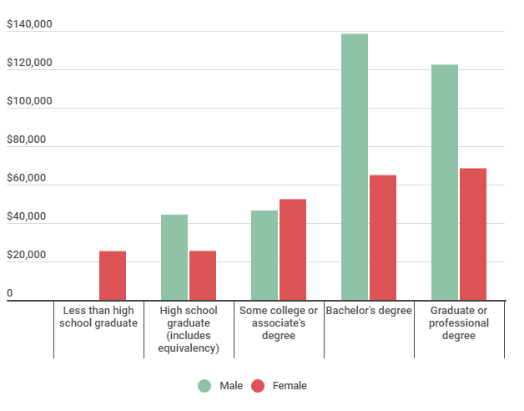
The wage numbers need to be formatted in the SETTINGS function:
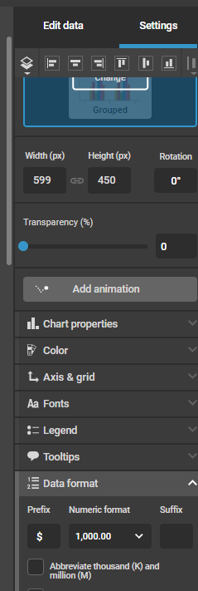
Choose the 1000 with the comma and place the $ in the prefix. I caution students that not doing this might mean folks see the whole number as population, not wages!

In doing this, students are demonstrating the “recognize the implications of information formats that contain static or dynamic information” from the ‘Information Creation as a Process’
The chart is not enough though to accurately portray the reality of the amount of actual people in each of the educational attainment categories.
We need to add the percentages of males in each category and the percent of females likewise.

Students would often say that one chart was enough, but if there is only one women with a graduate degree, and many men, the bars in the grouped chart would not be suitable to make any claim as to whether men make more than women in that statistic!

We add two charts, one for men and one for women of the ‘Size Comparison’ type:
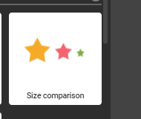
Using the population percent in the table from the census we have been working with. It is important to point out that one must take from the same age range to accurately portray the data. 25 and above in age, which is what the wage data was revealing.
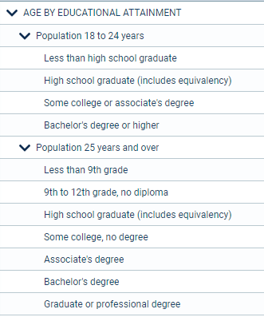
Same age grouping as the wages data
Use the labels appearing above in the A2 of the EDIT function, label B! Male and paste in the percents from the male category:
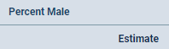

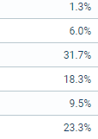
The chart will appear like this:
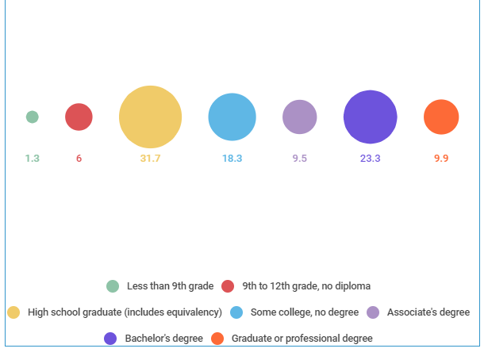
This needs to reflect it is Male data!

To make it clear this is data for Males, go to the Settings function, then choose ‘Chart Properties’
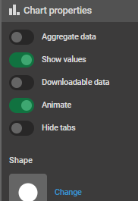
And change the “Shape” to a little man
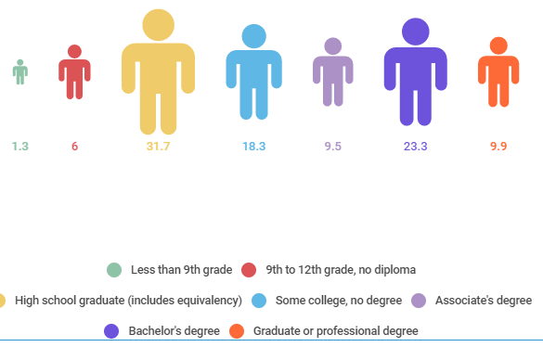
Do another new size comparison for the female data and choose the little woman shape

Here I discuss how statistics can be skewed or not in this way by the added or excluded data that could make better sense of a chart. I emphasize that going to the source of the data and seeing it in its entirety is the gold standard and worthy of becoming familiar with for best success.
We go on to see what stands out (Men make more than women! Degree-holders make more than non-degree-holders!) and how the visual presentation makes it clear.
More research questions arise from viewing the data this way. What industries are in the zip code? Rural or urban?
Added value/Second session ideas: Create citations for the infographic (students love to see their own names on a citation!) and for the source of the data (Citing a table). Develop search strategies in the database based on new insights for scholarly articles on wage gaps and educational attainment. Develop new branching research questions based on the information brought out in the infographic.
Connecting with the framework ‘Information has Value’ – the knowledge practice: “understand how and why some individuals or groups of individuals may be underrepresented or systematically marginalized within the systems that produce and disseminate information” we saw that race was not represented, and non-binary gender’s data is not gathered at all by the census.
There are so many ways one can devise a second session generated by this activity.
I find that the more academically motivated students are thankful to see the value of going to the actual source of data, and feeling pride in gathering the datasets themselves to make a point or to discover new and interesting points that arise out of this process that they may not have considered at the beginning.
We started to find out how many people in their hometown zip code had bachelor degrees and ended up with a reason, albeit a financial one, to stay and finish their degree, or to advocate for wage equality.
Please contact me with any questions or concerns:
Stella Herzig
St Ambrose Library,
518 West Locust St.
Davenport IA 52803

herzigstellaj@sau.edu
563-333-6056

