Narrative & Media Rhetoric
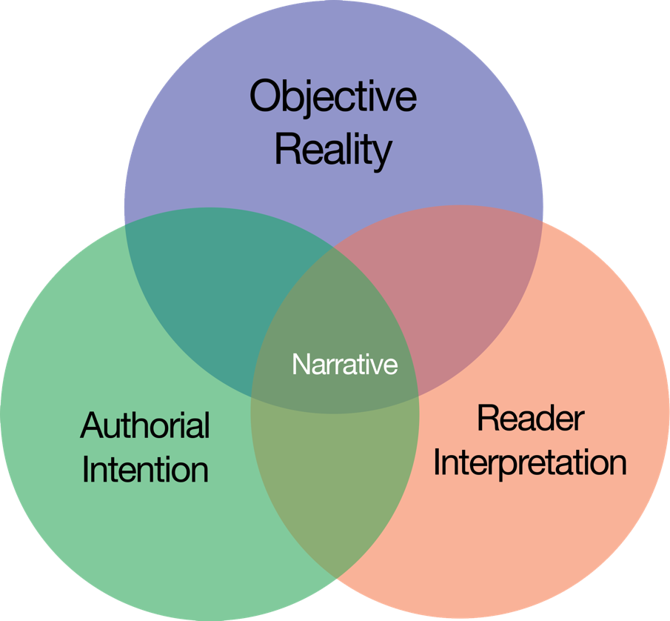

Definitions:
“Narrative” – a spoken or written account of connected events; a story.
Objective Reality is not subjective. It exists and does not change depending on who is looking at it. It’s what happened, regardless of what anyone may think. People looking at the same objective reality from different angles will, inevitably, see it differently.
Authorial Intention, as you may suspect, is what the author would like to convey through their writing.
Reader Interpretation is the impact this writing actually has on the reader. It is important to note that sometimes a reader will interpret a piece of writing as the author intended it to be interpreted, and sometimes they will not.
“Bias” - consciously or unconsciously viewing a word through a particular lens constructed by belief systems, experiences, and individual perspectives.
Both Authorial Intention and Reader Interpretation are rooted in perspective. The attitude and outlook of the person doing the writing, or the reading will impact what they think about the topic and why.
“Rhetorical Situation” - the circumstance of an event that consists of an issue, an audience, and a set of constraints. In this case, the audience is us and the event is the speaker’s original words as they are translated through levels of interpretation.

Discussion:
The purpose of this activity is to recognize how a quote can be taken out of context in subtle (and overt) ways. The goal is to locate a quote within a news article and trace it through multiple layers of context to discover how journalists’ interpretations of quotes impact our understanding of actual events and news.
Because quotations can be interpreted, it is important to examine the source in its original context so that we are in a better position to understand others’ interpretation and use of quotations. If we cannot locate the original context, the quotation’s authenticity should be in question.
If the original speaker is widely “quoted,” then locating a variety of interpretations from secondary sources can be valuable. Such work will enable us to understand and examine the larger picture and the social narratives.
Every aspect of a text is a choice made by its creators (the initial speaker and additional influencers). Therefore, it is important for us to analyze:
- how a quote came to be (how it was created and by whom)
- the influence additional circumstances have on that quote (for instance, how it was distributed and various contexts in which it might appear)
- the effects of journalistic choices and subsequent factors that shape the quote
Narratives are the story in which objective realities merge with interpretations and intentions. In this activity, we will be examining the rhetorical situation between quotes and the journalist’s perspective of the situational context.
Bias can obscure what actually happened. Be critical thinkers about news sources you encounter vs. hearing a story that is told secondhand. Whenever possible, we should aim to find the original content, and use logic and reasoning to arrive at a conclusion.
Quotes are often used as evidence for particular claims. The same quote will sometimes be used as evidence for vastly different claims, even those that contradict each other. For this activity, we are not claiming that a speaker’s quote is factual or that a journalist’s interpretation is accurate. Here, the only fact is that the speaker did say the words and they were (hopefully) quoted accurately.
For this assignment, you are focusing on these key people in media:
- Speaker - The direct source, the individual who is being quoted in the media.
- Journalist - The person who is quoting the speaker in writing.

Quote Tracing Activity

Part 1: Locating a quote within a news article
Locate an article that has been circulating on your social media pages – or in mass media more generally. The best articles for this activity are sociopolitical in nature – that is, they cover events that are both social and political). Make sure that the journalist uses quotes within the news article. Use the chart below to document the quote.
News Source | Provide the entire sentence(s)  in which the journalist quotes the original speaker. | Describe the authorial intention? What story is the author supporting with this quote?

Part 2: Tracing the quote
Locate the original context of the speaker’s quote. For example, if it is a part of a political speech, watch the original speech. Next, write a neutral summary of the original speaker’s quote.
Where did the journalist get the original speaker’s quote? | Write a neutral summary of the original speaker’s quote.

Part 3: Exploring the quote
Choose three different news sources that use the same quote as the author from Part 1 and examine how the quote is used within each context. Each source may present a different perspective or narrative regarding the quote. To do this, search the quote in Google and select the news filter.
News Source and link to article | Article Title | Does the title accurately describe the content of the article? If not, explain. | Describe the authorial intention? What story is the author supporting with this quote?
(Example: CNN, link)

Part 4: Reflection
In at least three paragraphs, respond to the following prompts, comparing the use of the quote in different news articles.
- How did the narrative or context of the speaker’s quote change in each of the news sources?
- Did the author’s presentation of the quote change the meaning of the original text?
- Explain the bias or how the news source appears impartial.
- Why do you think changes to the quotes or changes in the supporting narrative were made?
  - What affect do these changes have on us as readers?

