PSCI Curriculum Map
  - Procedural Manual & Codebook

Brea Henson, MA, MLS
Outreach and Instruction Librarian
Political Science Librarian

University Libraries,
University of North Texas
March 20, 2020

Table of Contents
Introduction to the Curriculum Map 4
Timeline 4
Preparation 4
Formatting 4
Updating the Codebook 5
Coding with the Codebook 5
Generating Data 5
Assessment Summary 5

Codebook for PSCI Curriculum Map
How to Use the Codebook 6
ACRL Framework for Information Literacy for Higher Education 8
Authority is Constructed and Contextual – Literacy Code: AC 8
Information Creation as a Process – Literacy Code: IP 10
Information has Value – Literacy Code: IV 11
Research as Inquiry – Literacy Code: RI 11
Scholarship as Conversation – Literacy Code: SC 13
Searching as Strategic Exploration – Literacy Code: SE 14
AAC&U Information Literacy Value Rubric 15
Determine the Extent of Information Needed – Literacy Code: DE 15
Access the Needed Information – Literacy Code: AI 15
Evaluate Information and its Sources Critically – Literacy Code: EI 15
Use Information Effectively to Accomplish a Specific Purpose – Literacy Code: UI 16
Access and Use Information Ethically and Legally – Literacy Code: EL 17

Data Analysis for PSCI Curriculum Map
Literacy Code Data Sheets 18
Frequency Distribution Table & Chart in Excel 18
Adding Percentages & Editing Histogram Chart 20
Total Frequency & Percentage Sheet 25
Bins | Code Summary Frequency Table 25
Course Analysis Frequency Table 26
Course Analysis Frequency Table 27
SLO Representation Sheet 29
Population VS Sample Note 29
SLO Representation and Frequency Sample Set Tables 29
Percentage Sample Removed Table 31
SLO Percentages in Sample Set Table 32
Objectives Represented in PSCI Syllabi Table & Chart 32

Assessment Narrative for PSCI Curriculum Map
Writing an Executive Summary 35

Introduction to the Curriculum Map
This document provides directions and information need to complete a curriculum for the Political Science Department at the University of North Texas. Other subject librarians may use this document to guide their own curriculum mapping projects.

Timeline
Every spring semester, course syllabi should be downloaded from FIS to ensure the maximum number for syllabi will be available for the map updates. The Curriculum Map should be updated every three years to include these additional courses and sections by following the documentation provided. After each decade a report indicating the progress of the department should be created. After each report, the librarian may decide no further mapping needs to be completed.

Schedule
- FY 2020: Initial Map of FA2017-SP2020 PSCI Courses
- FY 2023: Update of FA2020-SP2023 (as new workbook)
- FY 2026: Update of FA2023-SP2026 (as new workbook)
- FY 2029: Update of FA2026-SP2029 (as new workbook)
- FY 2030: Decade report (combine pervious workbook in new workbook)

Preparation
At the beginning of the new mapping cycle, the librarian should contact the Office of the Registrar (registrar@unt.edu) to obtain course schedules for the semesters that need to added to the project. Ask the registrar for an excel file. Locate PSCI course and delate all other disciplines. Divide ungraduated and graduate courses into different spreadsheets. Save using naming conventions Semester Year_PSCI Class Listing.
Ex: Spring 2020_PSCI CLASS LISTING

Formatting
A new excel file needs to be created for each scheduled iteration of the project. Each file should have an assessment summary page, registrar check list, PSCI Y####-#### matrix, Total Code Representation, and Individual SLO Representation sheets. Additional sheets will be added during the data process. These individual files will provide snapshots of the progress of PSCI courses to meet information literacy expectations. The files can then be combined to create a decade report.

Matrix
Copy semester, name, number, section, and instructor name for each class provide in the Semester Year_PSCI Class Listing. Sort rows so the top rows are the most recent courses.

Updating the Codebook
At times, librarian may choose add additional objectives from syllabi that have not been already included in the sample list. When coding additional objectives, copy and paste the objective under its appropriate threshold code.

Coding with the Codebook
Librarian should review the sample of PSCI syllabi to complete coding matrix. Librarian or student employee will match syllabi to threshold samples from the codebook and then add the appropriate numerical Bin Codes into the matrix spreadsheet. A student employee may assist with the coding process. Additional comments are provided in the Codebook for PSCI Curriculum Map section.

Generating Data
The data used in the analysis will most be frequency, percentage, and average data. In addition to the Matrix, there will be 13 data sheets. Eleven of these sheets will be frequency and percentage of each Literacy Code. One sheet will have three summative frequencies and percentages titled “Total Frequencies & Percentages.” Another sheet will have a summative Literacy Code titled “SLO Representation. “
After matrix is complete, frequency and percentages tables of each code and threshold will be created. Frequencies are generated using the Data Analysis-Histogram function in Excel. Percentages are calculated manually using the equation: ((Frequency #)/ (Total Code #)) X100. Edit the Histogram Chart to add percentages to the table and chart. Additional comments and instructions are provided in the Data for PSCI Curriculum Map section.

Assessment Summary
In the assessment summary, provide a narrative of data sample including number of classes, mode of sections offered per courses reviewed, totals of code and percentages of 0, 1, and 3. The narrative should also capture the percentage of faculty that provide their syllabus in FIS and the percentage of faculty that provide SLOs on their syllabus. Further, using 6 as the average number of SLOs provide on the syllabi estimate the percentage of language representing and not representing threshold language.

Codebook for PSCI Curriculum Map
The codebook is designed to be used to code the curriculum of the Political Science department at the University of North Texas using the threshold concepts of the ACRL Framework and AAC&U Information Literacy Value Rubric.
Each threshold, definition, and criteria are provided in this document as well as direct language from PSCI syllabi that correlates to each threshold. The sample of syllabi language is not exhaustive as syllabi with distinct, bullet-pointed course or learning objectives were only selected.

How to Use the Codebook
Librarian should review this document along with the sample of PSCI syllabi to complete coding matrix. Librarian will match syllabi to threshold samples from the codebook and then add the appropriate numerical Bins | Codes into the matrix spreadsheet. At times, librarian may choose to provide codes to additional objectives on syllabi that have not been already included in the sample list. When coding additional objectives, copy and paste the objective into the codebook.
Bins | Codes are list below for reference. In most cases, syllabi without bulleted learning objectives will be marked 3 (SLOs not on Syllabi as Learning Outcomes).
Bins | Codes | Meaning
0 | Standard or Frame is not indicated
1 | Standard or Frame is indicated
2 | Syllabi not available of FIS at Time of Analysis
3 | SLOs not on Syllabi as Learning Outcomes
4 | Download Error

After the matrix is complete, the coding process stops, and the next steps are taken.

Example
- Review Syllabi from PSCI 2300 and compare to Codebook. If objectives are listed, course will receive a 0 or 1 in the matrix.
- “Formulate research questions and hypotheses” is a listed course or learning objective.
- In the Codebook, “formulate research questions and hypotheses” is listed under Authority is Constructed and Contextual – Code: AC. The codes match. A 1 will be marked in the matrix.
- In the matrix, find the course syllabi you are reviewing and the threshold code. Place a 1 in the cell as shown below.
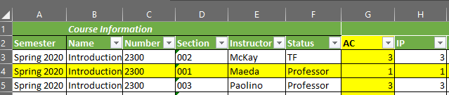
- Continue process until the matrix is completed

ACRL Framework for Information Literacy for Higher Education
Information literacy is the set of integrated abilities encompassing the reflective discovery of information, the understanding of how information is produced and valued, and the use of information in creating new knowledge and participating ethically in communities of learning.

Authority is Constructed and Contextual – Literacy Code: AC
Information resources reflect their creators’ expertise and credibility, and are evaluated based on the information need and the context in which the information will be used. Authority is constructed in that various communities may recognize different types of authority. It is contextual in that the information need may help to determine the level of authority required.
Experts understand that authority is a type of influence recognized or exerted within a community. Experts view authority with an attitude of informed skepticism and an openness to new perspectives, additional voices, and changes in schools of thought. Experts understand the need to determine the validity of the information created by different authorities and to acknowledge biases that privilege some sources of authority over others, especially in terms of others’ worldviews, gender, sexual orientation, and cultural orientations. An understanding of this concept enables novice learners to critically examine all evidence—be it a short blog post or a peer-reviewed conference proceeding—and to ask relevant questions about origins, context, and suitability for the current information need. Thus, novice learners come to respect the expertise that authority represents while remaining skeptical of the systems that have elevated that authority and the information created by it. Experts know how to seek authoritative voices but also recognize that unlikely voices can be authoritative, depending on need. Novice learners may need to rely on basic indicators of authority, such as type of publication or author credentials, where experts recognize schools of thought or discipline-specific paradigms.
- Formulate research questions and hypotheses
- Design a research project involving data analysis
- Use statistical programs like SPSS to conduct research
- Compose theories that generate hypotheses
- Design empirical research projects
- Understand the necessary components of a research paper
- articulate policy arguments for or against governmental infringement into individual right
- Shepardize and cite cases
- format a law review article
- Engage in analogical reasoning and employ other tools of legal analysis
- All goals mentioned for 3100: Free Expression on the American University Campus
- Explain the theoretical basis of women’s political interests and consider how the intersections of gender, race, ethnicity, class, sexuality, and ideological and partisan identifications shape and create multiple perspectives on those interests;
- learning what Socrates meant by “Know Thyself,” that is, by liberating your heart and mind from the compelling pressure of authoritative conventions
- Understand the basic logic of the methods of comparative political analysis
- Understand the importance of political institutions, social relations, social movements, and diversity in Latin American context.
- Understand the relationships between authoritarianism, democracy, democratic transition and democratic consolidation in Latin America.
- To assess and critique theories of economic development …;
- To assess and critique theories of economic policy choice under military rule;
- To assess and critique theories about the breakdown of democratic rule;
- To assess the history of US relations with our southern neighbors and their possible impact on current and future events;
- To assess and critique theories to explain important issues (e.g., immigration, trade, sanctions, etc.) that affects Latin America and the US.
- Employ a theoretical framework for analyzing contemporary global problems
- Students will be able to identify the major theoretical schools of international relations and describe their central theoretical arguments and assumptions.
- Students will be able to discuss the role of power in explaining actor behavior in the international system.
- understand and discuss the past and current socio-political climate of the Supreme Court's decisional process;
- understand and discuss legal concepts utilized by the courts in criminal cases;
- understand and discuss recent trends in decision-making regarding criminal procedural rights;
- understand and discuss the legal underpinnings and parameters of jurisprudence in criminal cases;
- understand and discuss current standards and legal tests utilized by the federal courts in deciding cases;
- Describe the evolution of feminist political theory over the history of political thought
- Describe the relationship between feminist political theory and more general theories of philosophy
- Understand behavioral and institutional theories of ethnic conflict and conflict management
- Demonstrate an understanding of the main theoretical approaches to studying post-conflict transitional justice and human rights;
- Recognize the interdisciplinary dimension as well as the application of these topics to other disciplines.
- To assess and critique theories about privatization.
- To assess and critique theories of globalization.
- To assess and critique the history of US relations with developing countries and their possible impact on current and future events.
- To assess and critique theories linked to important issues (e.g., immigration, trade, sanctions, multinational corporations, and urbanization) that affect developing countries.
- To demonstrate awareness and knowledge of cultural differences within one of more global societies (Outside the U.S.).
- Identify and explain the secularization thesis
- Explain theoretical approaches to comparative politics.
- Explain how these various theoretical approaches have been applied to the study of developing countries.
- Explain how political culture and economic development patterns have affected political development.
- Explain the role of ethnic plurality in political and social development.
- Explain the role that the military has played in the political and social development.
- Explain the how the Third Wave of democracy has affected developing counties.
- Explain the role of political institutions in developing countries.

Information Creation as a Process – Literacy Code: IP
Information in any format is produced to convey a message and is shared via a selected delivery method. The iterative processes of researching, creating, revising, and disseminating information vary, and the resulting product reflects these differences.
The information creation process could result in a range of information formats and modes of delivery, so experts look beyond format when selecting resources to use. The unique capabilities and constraints of each creation process as well as the specific information need determine how the product is used. Experts recognize that information creations are valued differently in different contexts, such as academia or the workplace. Elements that affect or reflect on the creation, such as a pre- or post-publication editing or reviewing process, may be indicators of quality. The dynamic nature of information creation and dissemination requires ongoing attention to understand evolving creation processes. Recognizing the nature of information creation, experts look to the underlying processes of creation as well as the final product to critically evaluate the usefulness of the information. Novice learners begin to recognize the significance of the creation process, leading them to increasingly sophisticated choices when matching information products with their information needs.
- Understand how to use statistical programs like SPSS to conduct such research
- Formulate research questions and hypotheses
- Design a research project involving data analysis
- Formulate puzzles, research questions, and review current literature
- Design empirical research projects
- Understand the necessary components of a research paper
- Refine grammar, syntax, diction, and clarity in your writing.
- Work collaboratively to both give and receive criticism in the process of improving the quality of your work
- Decompose a large project into smaller more manageable components
- Devise your own solutions to address these problems
- Identify and describe new puzzles or questions in feminist political thought

Information has Value – Literacy Code: IV
Information possesses several dimensions of value, including as a commodity, as a means of education, as a means to influence, and as a means of negotiating and understanding the world. Legal and socioeconomic interests influence information production and dissemination.
The value of information is manifested in various contexts, including publishing practices, access to information, the commodification of personal information, and intellectual property laws. The novice learner may struggle to understand the diverse values of information in an environment where “free” information and related services are plentiful and the concept of intellectual property is first encountered through rules of citation or warnings about plagiarism and copyright law. As creators and users of information, experts understand their rights and responsibilities when participating in a community of scholarship. Experts understand that value may be wielded by powerful interests in ways that marginalize certain voices. However, value may also be leveraged by individuals and organizations to effect change and for civic, economic, social, or personal gains. Experts also understand that the individual is responsible for making deliberate and informed choices about when to comply with and when to contest current legal and socioeconomic practices concerning the value of information.
- Identify good sources of information
- Demonstrate creative thinking, innovation, analysis, evaluation, and synthesis of information

Research as Inquiry – Literacy Code: RI
Research is iterative and depends upon asking increasingly complex or new questions whose answers in turn develop additional questions or lines of inquiry in any field.
Experts see inquiry as a process that focuses on problems or questions in a discipline or between disciplines that are open or unresolved. Experts recognize the collaborative effort within a discipline to extend the knowledge in that field. Many times, this process includes points of disagreement where debate and dialogue work to deepen the conversations around knowledge. This process of inquiry extends beyond the academic world to the community at large, and the process of inquiry may focus upon personal, professional, or societal needs. The spectrum of inquiry ranges from asking simple questions that depend upon basic recapitulation of knowledge to increasingly sophisticated abilities to refine research questions, use more advanced research methods, and explore more diverse disciplinary perspectives. Novice learners acquire strategic perspectives on inquiry and a greater repertoire of investigative methods.
- Identify good sources of information
- Formulate research questions and hypotheses
- Design a research project involving data analysis
- Employ basic statistical methods to test hypotheses about politics
- Understand the necessary components of a research paper
- Conduct appellate court research
- Engage in basic legal research using Lexis and other online research databases
- Develop reading, writing and research capacities and to think critically and creatively
- Execute a research paper that demonstrates critical thinking, the ability to apply course concepts, and the sound judgement on the between reliable and unreliable information
- Complete a written, critical analyses of how one female member of Congress effectively represented women and campaigned for re-election.
- Provide a written, critical analysis of an interest group or advocacy organizations, lobbying strategy.
- articulate a cogent legal argument and that you conduct research on
- Write a coherent and concise term paper on a topic of interest as it relates to some aspect of
Latin American Politics
- Understand political science theories relating to civil war and conflict resolution
- Present thoughtful and well-written statements about current international political issues by conducting comparative analysis and in-depth research of key topics
- Utilize political science theories and approaches to research contemporary anti-Semitism
- Devise and assess research designs and projects for understanding the role and impact of transitional justice, and in particular legal mechanisms.
- Conduct independent research on the institutions and behaviors associated with transitional justice experiences in a variety of contexts;
- Develop analytical and statistical skills by using computer packages including, introductions to STATA and Excel;
- Write a coherent and concise term paper on a topic of interest as it relates to the judiciary, democratic development, and the rule of law.
- Write a coherent and concise term paper on a topic of interest as it relates to political development.
- write interpretive essays that present complex and subtle arguments in clear and persuasive fashion

Scholarship as Conversation – Literacy Code: SC
Communities of scholars, researchers, or professionals engage in sustained discourse with new insights and discoveries occurring over time as a result of varied perspectives and interpretations.
Research in scholarly and professional fields is a discursive practice in which ideas are formulated, debated, and weighed against one another over extended periods of time. Instead of seeking discrete answers to complex problems, experts understand that a given issue may be characterized by several competing perspectives as part of an ongoing conversation in which information users and creators come together and negotiate meaning. Experts understand that, while some topics have established answers through this process, a query may not have a single uncontested answer. Experts are therefore inclined to seek out many perspectives, not merely the ones with which they are familiar. These perspectives might be in their own discipline or profession or may be in other fields. While novice learners and experts at all levels can take part in the conversation, established power and authority structures may influence their ability to participate and can privilege certain voices and information. Developing familiarity with the sources of evidence, methods, and modes of discourse in the field assists novice learners to enter the conversation. New forms of scholarly and research conversations provide more avenues in which a wide variety of individuals may have a voice in the conversation. Providing attribution to relevant previous research is also an obligation of participation in the conversation. It enables the conversation to move forward and strengthens one’s voice in the conversation.
- Explain quantitative results
- Explain quantitative results to a person who did not take this class
- Explain the difference between causation and correlation
- Effectively communicate research findings
- brief court decisions.
- argue principles involved in Constitutional cases.
- articulate policy arguments for or against governmental infringement into individual rights
- present appellate court arguments
- Communicate using proper grammar and diction, with a more elegant style
- write interpretive essays that present complex and subtle arguments in clear and persuasive fashion
- Provide future employers or graduate/professional schools with a writing sample published in UNT’s constitutional journal, the Emerald Amicus.
- students will effectively develop, interpret, and express ideas through written, oral, and visual communication
- Formulate an original opinion about international relations in today’s globalized world
- Present thoughtful and well-written statements about current international political issues by conducting comparative analysis and in-depth research of key topics
- discuss some findings of the scholarly community and apply our understanding to current events
- Enhance critical writing capacity by preparing independent research on critical questions in post-conflict studies regarding the effectiveness and impact of transitional justice mechanisms following war;

Searching as Strategic Exploration – Literacy Code: SE
Searching for information is often nonlinear and iterative, requiring the evaluation of a range of information sources and the mental flexibility to pursue alternate avenues as new understanding develops.
The act of searching often begins with a question that directs the act of finding needed information. Encompassing inquiry, discovery, and serendipity, searching identifies both possible relevant sources as well as the means to access those sources. Experts realize that information searching is a contextualized, complex experience that affects, and is affected by, the cognitive, affective, and social dimensions of the searcher. Novice learners may search a limited set of resources, while experts may search more broadly and deeply to determine the most appropriate information within the project scope. Likewise, novice learners tend to use few search strategies, while experts select from various search strategies, depending on the sources, scope, and context of the information need.
- Identify good sources of information
- Find legal documents
- Investigate the intersections of sovereignty and human rights within the context of post-conflict mechanisms, and devise methods for studying these questions;

AAC&U Information Literacy Value Rubric
The ability to know when there is a need for information, to be able to identify, locate, evaluate, and effectively and responsibly use and share that information for the problem at hand. -Adopted from the National Forum on Information Literacy

Determine the Extent of Information Needed – Literacy Code: DE
Effectively defines the scope of the research question or thesis. Effectively determines key concepts. Types of information (sources) selected directly relate to concepts or answer research question.
- Formulate research questions and hypotheses
- Design a research project involving data analysis
- Understand the necessary components of a research paper

Access the Needed Information – Literacy Code: AI
Accesses information using effective, well designed search strategies and most appropriate information sources.
- Identify good sources of information
- Engage in basic legal research using Lexis and other online research databases
- Employ other tools of legal analysis
- Acquire knowledge of the foreign policies of a variety of countries around the world
- Acquire knowledge and tools to understand crime, violence and justice concepts from theoretical, comparative and empirical perspectives.
- Identify and explain the secularization thesis

Evaluate Information and its Sources Critically – Literacy Code: EI
Thoroughly (systematically and methodically) analyzes own and others' assumptions and carefully evaluates the relevance of contexts when presenting a position
- Explain quantitative results
- Understand how to use statistical programs like SPSS to conduct such research
- good sources of information
- think critically about issues of race and how they are employed in our national politics
- Formulate the questions of ancient and medieval political theory in contrast with early modern political theory concerning the best life, the best regime, and the overall relationship between the individual and society, with a special focus on the relationship between religion and politics
- Assess the relative impact of these human security problems and their potential for leading to long-term harm in the affected countries.
- Assess the factors that explain why these problems occur and describe in written and oral form the most important findings from social science research on these problems.
- Analyze and synthesize the various approaches that have been taken in conflict nations to sustain the peace, such as democracy development and the use of transitional justice, and determine which solutions work best under various conditions.
- Reflect, analyze, and express beliefs about the ways in which culture influences both perception and behavior.
- Students will demonstrate creative thinking, innovation, analysis, evaluation, and synthesis of information.
- Reflect, analyze, and express theoretically informed judgments about the foreign policy decisions and behaviors of different countries

Use Information Effectively to Accomplish a Specific Purpose – Literacy Code: UI
Communicates, organizes and synthesizes information from sources to fully achieve a specific purpose, with clarity and depth
- Formulate research questions and hypotheses
- Design a research project involving data analysis
- Understand how to use statistical programs like SPSS to conduct such research
- Employ basic statistical methods to test hypotheses about politics
- conduct appellate court research
- argue principles involved in Constitutional cases.
- articulate policy arguments for or against governmental infringement into individual rights
- brief court decisions.
- present appellate court arguments
- Engage in analogical reasoning
- learning to read challenging, careful, sometimes muted arguments as presented in a variety of forms (drama, treatise, dialogue) from difficult authors and expressing interpretations of them in exegetical essays
- write interpretive essays that present complex and subtle arguments in clear and persuasive fashion
- decipher how it was done by the masters (including Socrates and Plato), and how they enable us to analyze and evaluate our situation, in particular the customary or conventional opinions through which we approach political questions
- Engage in deep reading and regular writing as part of the practice of studying political theory.
- Explain the various factors affecting human security throughout the world and explain why some human security problems are more prevalent in some countries and under some circumstances than others
- Explain the various factors affecting human security throughout the world and explain why some human security problems are more prevalent in some countries and under some circumstances than others
- Ability to apply theories of comparative politics to contemporary issues
- Apply academic learning to real world problems
- Apply theories of conflict in Africa to current events and cases
- To assess and critique theories of economic development in Latin America;
- To assess and critique theories of economic policy choice under military rule;
- To assess and critique theories about the breakdown of democratic rule;
- To assess the history of US relations with our southern neighbors and their possible impact on current and future events;
- To assess and critique theories to explain important issues (e.g., immigration, trade, sanctions, etc.) that affects Latin America and the US.
- Demonstrate awareness and knowledge of cultural differences within one of more global societies (Outside of the U.S.).
- Present thoughtful and well-written statements about current international political issues by conducting comparative analysis and in-depth research of key topics
- Write a coherent and concise term paper on a topic of interest as it relates to political development.
- Ability to apply theories of ethnic politics to contemporary issues
- Construct pragmatic policy designed to counter the effects of anti-Semitic political actors domestically and abroad
- Learn how to examine trends in data, formulate and test hypotheses, read and analyze data using ordinary least squares regression and/or maximum likelihood estimation,
- Develop content for educational assessment and lead group discussions about topic areas developing policy expertise in a substantive issue area of international conflict;
- Offer an original contribution to address global problems
- Write a coherent and concise term paper on a topic of interest as it relates to political development.

Access and Use Information Ethically and Legally – Literacy Code: EL
Students use correctly all of the following information use strategies (use of citations and references; choice of paraphrasing, summary, or quoting; using information in ways that are true to original context; distinguishing between common knowledge and ideas requiring attribution) and demonstrate a full understanding of the ethical and legal restrictions on the use of published, confidential, and/or proprietary information
- Shepardize and cite cases
- Able to connect choices, actions, and consequences to ethical decision-making
Data for PSCI Curriculum Map
The data used in the analysis will most be frequency, percentage, and average data. In addition to the Matrix, there will be 13 data sheets. Eleven of these sheets will be frequency and percentage of each Literacy Code. One sheet will have three summative frequencies and percentages titled “Total Frequencies & Percentages.” Another sheet will have a summative tables of the Literacy Codes titled “SLO Representation Sheet.” You might want a calculator to assist with the equations.

Literacy Code Data Sheets

Frequency Distribution Table & Chart in Excel
After matrix is complete, frequency and percentages tables of each literacy code will be created. During this process, generate a sheet for the Frequency Distribution Table and Chart. There will be 11 of these in total, each named of the literacy code from the code book.
Frequency tables and histogram charts are generated using the Data Analysis-Histogram function in Excel. Percentages are calculated manually using the equation: ((Frequency #)/ (Total Code #)) X100 and added to the table.

Troubleshooting: Data Analysis Add-On
To make a frequency table using the histogram function, download the data analysis tool add-on for Excel. Once the add-on is activated, you can use the tool as shown in the following steps. If you need additional clarification on a step, review StatisticsHowTo.com.

Troubleshooting: Frequency Tables
Frequency tables do not have methods to add data easily to an existing table. As data is added to the project over time, new workbooks should be created to preserve legacy information from each analysis and reduce frustration in attempting to add data to an existing table. Matric data can be copied and pasted into a master workbook that can be used to complete Decade Report. However, should a method of way to add data and easily update table be found, then use that method.

Procedures
  - Highlight code column.
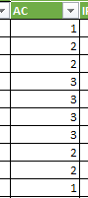
  - Click the “Data” tab. Then click “Data Analysis”.
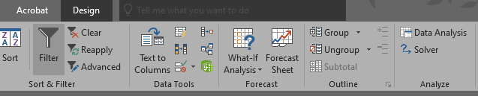
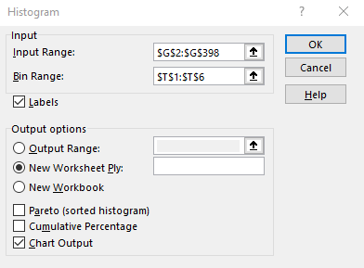
  - Click “Histogram” and then click “OK.”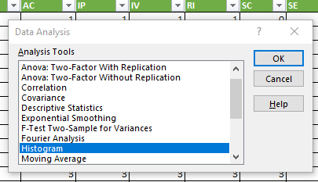
  - Type where your data is into the “Input Range” text box, type where your upper limits are into the “BIN Range” text box, and select “New Worksheet” as the output options. Click “Chart Output,” and then click “Ok.”

  - A new sheet will open that resembles the table below. Rename the sheet after the code analyzed by clicking on the sheet name. The sheets generated in these steps should be moved to after the matrix for organizational purposes.
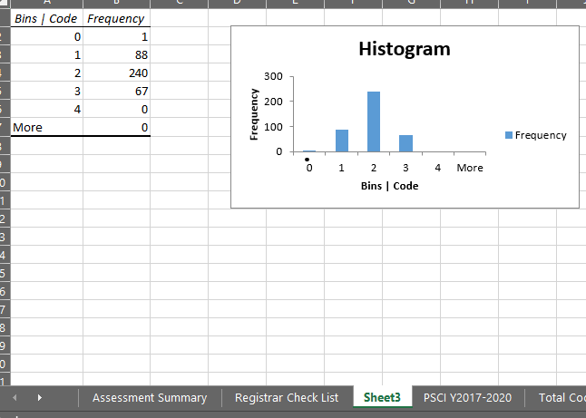
  - Repeat steps for each code.

Adding Percentages & Editing Histogram Chart
Percentages are calculated manually using equation: ((Frequency #)/ (Total Code #)) X 100.

Procedures
- Calculate percentages for each Bins | Code. Add them to cells next to the Frequency column. Label the new column Percentages and add cell lines.
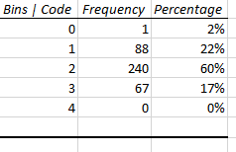
- Hover over the Histogram chart until the edit icons appear. Click on “Chart Filters.”
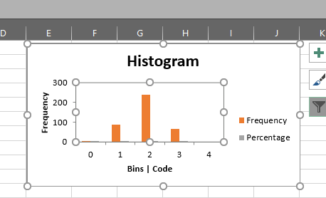
- Remove the “More” category if it was generated. Trouble shooting directions in red below. Then proceed by click on “Select Data” shown in black.
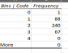
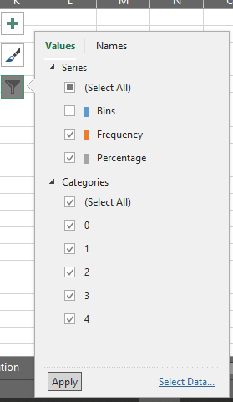
The “More” or “5” category would show up here in the filter. To remove it, de-select the box and Apply. Then delete the word “More 0” from the table.
- To edit data range, click in the range box and then highlight cells with label or write the range as shown.
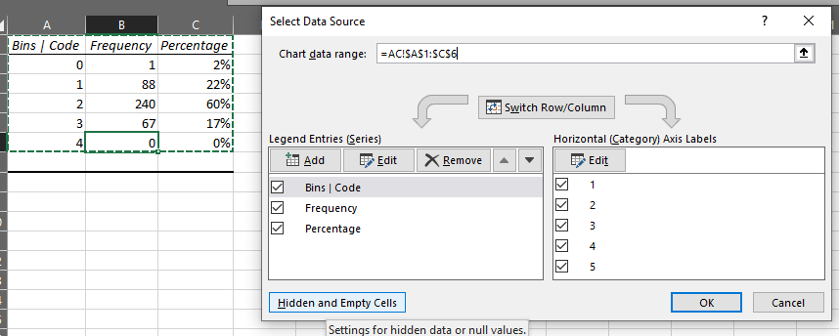
- If “Legend Entries (Series)” does not change automatically, click on the “Edit” button.
- Type is name of column in the “Series Name” box and click “Ok.” Repeat for each Series Labels.
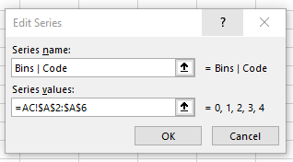
- To edit, “Horizontal (Category) Axis Labels, click the “Edit” button.
- Highlight Cell range of axis labels, and click “Ok.”
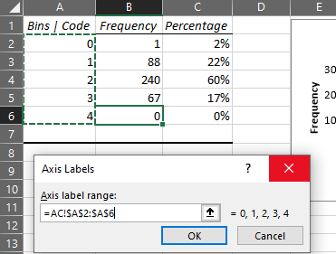

- This will return you to the “Select Data Source” pop up. De-select “Bins | Code” and finalize changes by clicking “Ok”.
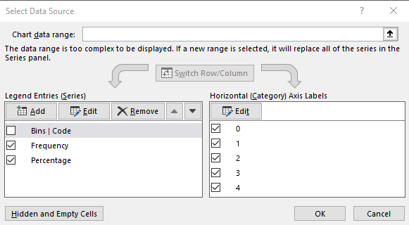

- Right click on chart area to change chart style.
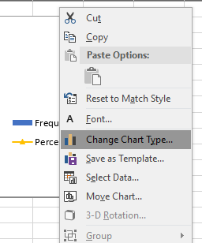
- Select Combo chart. Change Percentage to “Stacked Line with Markers” and click “Secondary Axis.” Click “Ok.”
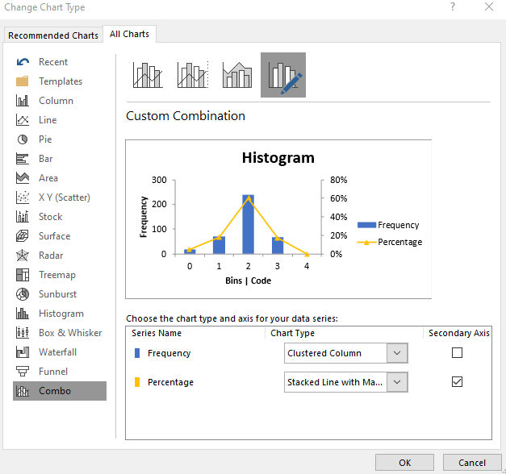
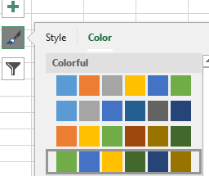
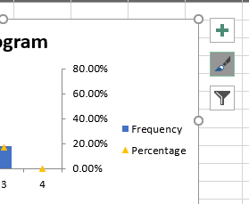
- Change color of chart by clicking on the “Chart Style.” Click “Color” and select “Color Palette 4” for better contrasting colors for accessibility.

- Troubleshooting Bins: When creating the second code chart, the bins were automatically added to the chart as a data point. Usually de-selecting it in the chart filter and ensuring the bins are selected in the “Horizontal (Axis) Labels” in the Select Data Source window removes them as a data point and keeps the axis names 0, 1, 2, 3, 4. I experienced that when doing this, the axis names would change to 1, 2, 3, 4, 5 and would change where the scatter points showed on the graph. If this happens, open the “Select Data Source” window and delete bins from the legend and reselect the axis names. Select Data Source Window should look like this.
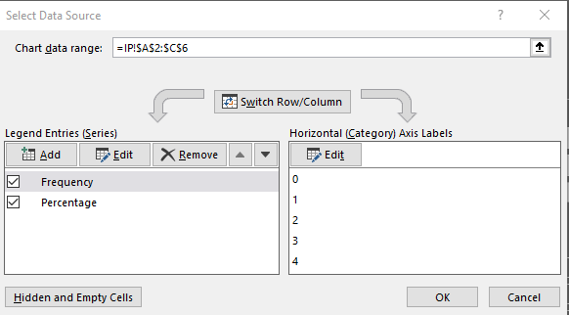
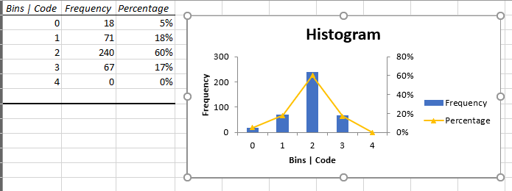
- Your final chart should look like the one to the left.

- Repeat steps for each code.

Total Frequency & Percentage Sheet
This sheet is meant to represent all Bins | Code totals as well as a summation of courses analyzed and codes in the matrix. You will generate one frequency table for all the codes, calculate other frequencies using basic subtraction, and numbers using basic multiplication. Percentages will also be calculated using the equation: ((Frequency #)/ (n or N)) X100. You may need a calculator.
This sheet will have three (3) frequency tables with percentages.

Bins | Code Summary Frequency Table
This table will have a summative view of all data in the literacy code sheets. Mirror the formatting of the other frequency tables.

Procedures
  - Row 1 will be the headers for the first table. Label them Bins | Code Summary, Frequency, and Percentage.
  - For this frequency table, instead of having the bin | code number in the subsequent rows, provide the code meaning and the number in parentheses. 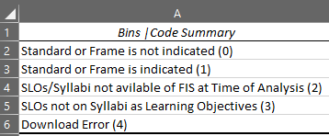
  - Then, go to the Matric sheet and highlight G2:Q398.
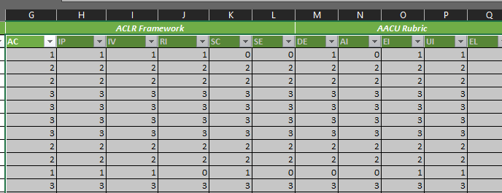
  - Go to the “Data” table, click on Data Analysis and select Histogram as before. Edit the Histogram “Input Range” to be G3: Q398 instead of G2:Q398. This will prevent an error message of text data in the input range. Uncheck “Chart Output.”
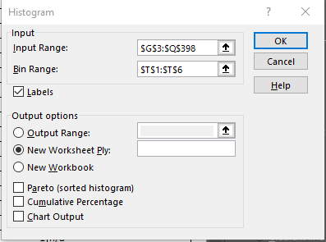
  - Copy frequency numbers into the “Total Frequency & Percentage Sheet.” Delete generated sheet.
  - Review Matrix sheet and located the last row with data. Note the number and subtract 2 for the row number. This give you the total number of classes reviewed. This number is N. Multiply N1 by 11 (there are 11 literacy codes) to get N2. Write these down somewhere to review.
  - Calculate percentages using the ((Frequency #)/ (N1 or N2)) X100 equation and type them in the frequency table.

Course Analysis Frequency Table
This table will have the total number of courses (N1) in the analysis and the portions of courses analyzed and removed from the analysis.

Procedures
- Skip row 7.
- Label cell A8: Course Analysis, B8: Frequency, and C8: Percentage.
- Label cell A9: Courses Analyzed (Code 0 + Code 1), A10: Courses Removed (Code 2 + Code 3 + Code 4), and A11: Total Courses (N1).
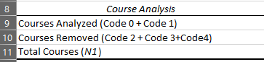
- Copy N1 into frequency cell.
- If you remember from the Literacy Code Sheets, the frequency for Bins | Code 2, 3, and 4 repeated in each sheet. Add these numbers together to get the sum of Courses Removed (Code 2 + Code 3 + Code 4). Subtract N from this number to get Courses Analyzed (Code 0 + Code 1). Type these numbers into the frequency column.
- Calculate percentages using the ((Frequency #)/ (N1)) X100 equation and type them in the frequency table.
- Copy N1 into cell A10 in al Literacy Code sheets.
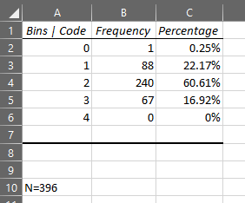

Course Analysis Frequency Table
This table will have the total number of codes (N2) in the analysis and the portions of codes analyzed and removed from the analysis.

Procedures
- Skip row 12.
- Label cell A13: Further Code Analysis, B13: Frequency, and C13: Percentage.
- Label cell A14: Codes Analyzed (Code 0 + Code 1), A15: Codes Removed (Code 2 + Code 3 + Code 4), and A16: Total Codes (N2).
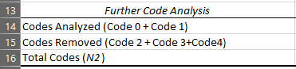
- Copy N2 into frequency cell.
- Review Bins | Code Summary Table. Add Codes 2, 3, and 4 and place in Codes Removed Frequency (Code 2 + Code 3 + Code 4) cell. Subtract N2 from this number to get Codes Analyzed (Code 0 + Code 1). Type these numbers into the frequency column.
- Calculate percentages using the ((Frequency #)/ (N2)) X100 equation and type them in the frequency table.

At the end of this process, the sheet should like the one below:
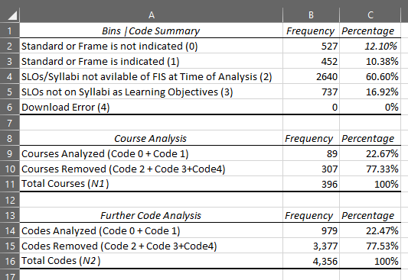

SLO Representation Sheet
This sheet will represent the majority of the data analysis for the summary and the other sheets will be used to create this sheet. The sheet will also involve an Excel Chart to provide a visual representation of the analysis. You may need a calculator.

Population VS Sample Note
When completing this stage of the analysis, you will need to decide if you want to use N1, N2, n1, or n2 as your total analysis number. In statistics, N is used to denote the total population and n is used to denote the sample of the population. N1, n1 are used in the analysis to denote the population and sample of classes. N2, n2 are used in the analysis to denote the population and sample of codes. It is important to decide which number you will use in the analysis and only use that number—this needs to be explained in the assessment narrative as well. The population or sample chosen should provide the most statistical significance to the analysis.
The tables and calculations in the following procedures were made using n1 after reviewing frequency and percentages.

SLO Representation and Frequency Sample Set Tables
The table provides a summary of the literacy code sheets. It only captures the frequency number of code 0 and code 1. The second table is a summative table of N1, n1, N2, n2.

Procedures
- Create a new sheet and label it SLO Representation
- Create a table as shown below:
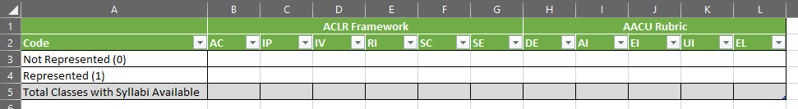
- Skip column between the above table and create a new table with the N1, n1, N2, n2 frequency sample set totals.
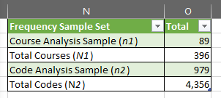

- Add n1 into the row 5 by using the formula =O2 in the formula box.
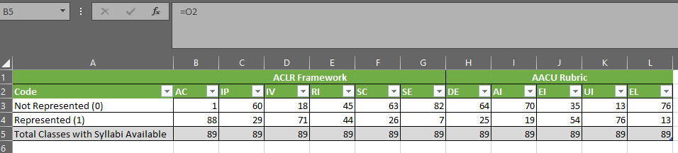
- Copy/Link frequency numbers of Bins | Codes 0 and 1 from the Literacy Code Sheets using the formula =SheetName!Cell#. For further directions on linking cells to copy text, view this webpage.
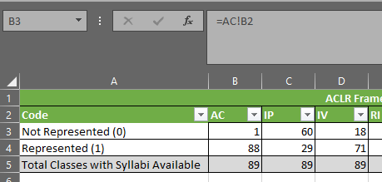

Chart Procedures
- To create a chart for the SLO table, highlight chart area A2:L4.
- Click on the “Insert” tab, and then click on the bar chart image.

- Click on the Chart Name to name the chart “SLO Representation in Syllabi.”

- Then click on the “Chart Filter” button, and click select dat.
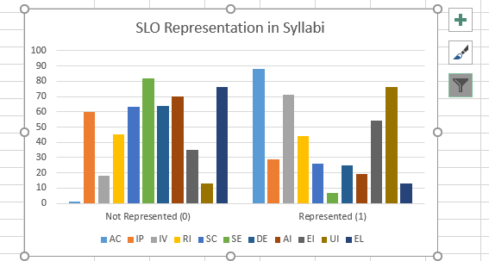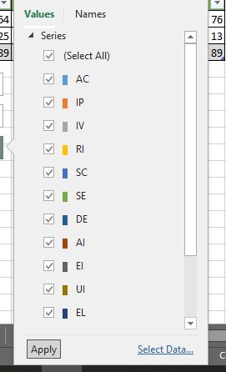
- Then click “Switch Row/Column” to change the legend and axis around.
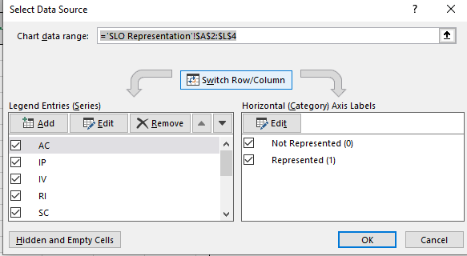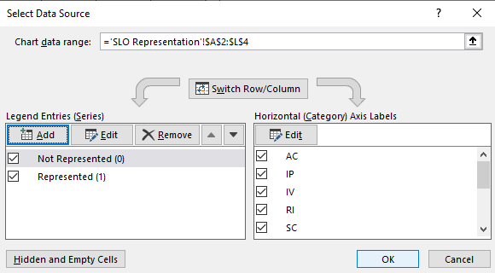
- Add PSCI and n1-89 descriptors to the chart title.
- Add data table to the chart and delete legend. The graph should resemble the one below.

Percentage Sample Removed Table
This table is important if you plan to remove any codes from the analysis and use n1 or n2 as the total data analyzed. If you use N1 or N2, then you do not need this table.

Procedures
- Create another table to the under the “Frequency Sample Set” called “Percentage Sample Removed”. Copy “Courses Removed (Code 2 + Code 3+Code4)” Percentage from “Total Frequency & Percentage” Sheet and percentages Bins | Code 2 & 3 from any Literacy Code Sheet. The table should look like the one below.
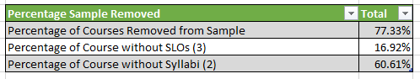
Unfortunately, this table does not visually display data well as a chart.

SLO Percentages in Sample Set Table
This table provides a summary of the percentages of each code and all as percentage of all courses with syllabi that were coded 0 or 1. The denominator will be which ever population or sample was chosen for the analysis. This the procedures below, n1 is used.

Procedures
- Create table under the table for the percentages of the sample set using the formulas below:
- Percentage of Courses with SLOS: (n1/N1) X100
- SLOs: ((Represented (1))/ (Total Classes with Syllabi Available)) X100
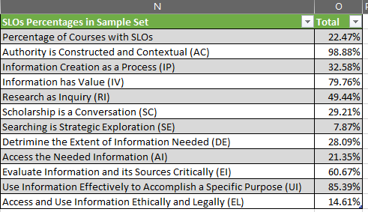
Unfortunately, this table does not visually display data well.

Objectives Represented in PSCI Syllabi Table & Chart
This table provides frequencies and percentages for SLOs coded only as represented or indicated with code 1.

Procedures
- Create a new table under the chart of table 1. Copy the threshold sections and table headers from table 1.
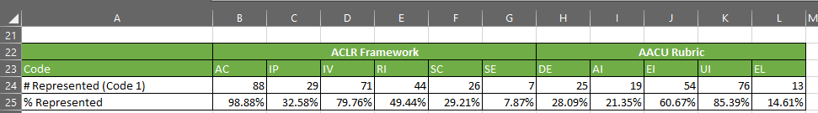
- Add row label “#Represented (Code 1)” to cell A24 and “% Represented” to A25. Link cells B4:L4 to cells B24:L24 using =Cell# formula. Then link cells O15:025 to cells B25:L25 using =Cell# formula.

Chart Procedures
- Create a custom chart for table 5 by highlighting A23:L25 data cells. Then go to the “Insert” tab and click “Recommend Charts”
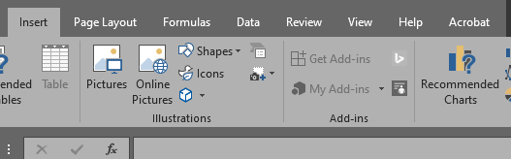
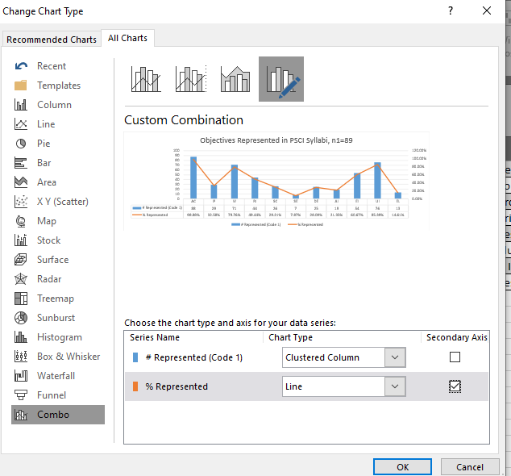
- This will bring up the “Change Chart Type” window. Navigate to “All Charts” tab and click on “Combo.” Make % Represented a Line or Stacked Line with Points and click “Secondary Axis.”

- Data table to chart and delete legend, and name chart “Objectives Represented in PSCI Syllabi, n1=89.”

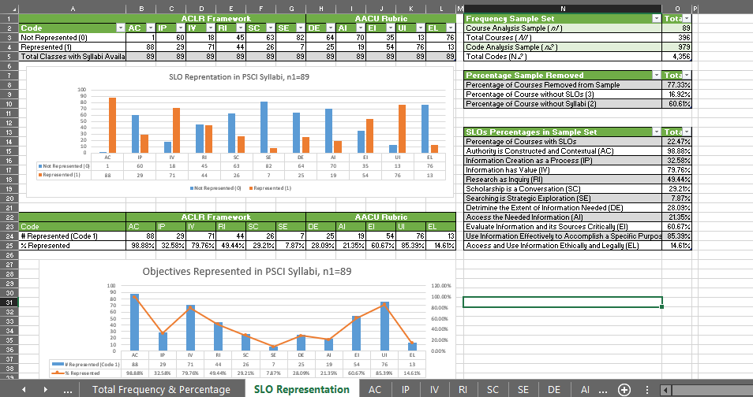
At the end of this process, the sheet should like the one below. Move the sheet after the “Total Frequency & Percentage” sheet and in front of the literacy code sheets.

You made decide later to add a frequency totals to the first SLO representation table. To provide further visual analysis use the data, use the “Conditional Formatting” feature and choose “Color Scale: Green-Yellow-Red” option.
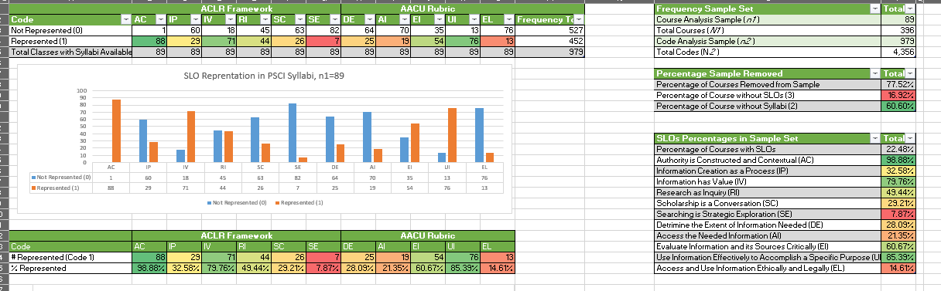
Assessment Narrative
Now that the data analysis is complete, an assessment narrative should be written to place the data in context with each other as well as describe the purpose of the data. The narrative only needs to be a few paragraphs in the form of an executive summary, but they can be expanded for article use at a later date as well.

Writing an Executive Summary
The assessment narrative is an executive summary of the data finding and results for the “Totally Frequency and Percentage” and “SLO Representation Sheet.” In addition to these numbers consider calculating
- the percentage of total syllabi provided in FIS,
- the total percentage of faculty that provide SLOs on their syllabi regardless of language representations,
- the total percentage of ACRL and AAC&U threshold language representation, and the total percentage of language used that did not represent an ACRL and AAC&U threshold concept.
- the average number of codes.
- An array of average SLOs per syllabi, or use 6 as the average number of SLOs per syllabi (this was the average used in the Core Curriculum assessment).
Depending on the data results, you should have chosen one total population or total sample integer (N1, N2, n1, n2) based on what would have provided the most statistical significance to the analysis. It is important to denote this in the assessment.
Lastly, review and make note of which literacy codes had the lowest frequency and percentages. Use the ACRL and AAC&U threshold guides to create sample SLOs that faculty could consider using to increase those percentages. These can be communicated with the narrative.

The assessment narrative should be written in MS Word and then pasted to a new sheet, placed at the front of the workbook. Title the sheet “Assessment Narrative” and provide a title to the paragraph(s). Merge cells as need so all text is visible.
Here is a sample of what an executive summary might look like. This narrative comes from a PSCI 2300 Curriculum Map sample project that was completed before the completion before the FY 2020: Initial Map of FA2017-SP2020 PSCI Courses. An image of how to format the spreadsheet is also provided. This sample uses N2 as the main integer of comparison which is different from the analysis steps showed in the Data Analysis Section.

Sample Narrative
In addition to the UNT Core Curriculum, the Political Science Department requires political science majors to enroll in PSCI 2300, a course that introduces students to quantitative and statistical research methods used in the Political Science Field. To provide a further analysis of SLO language representation used by UNT Political Science, ACRL and AAC&U threshold concepts should be mapped to the PSCI 2300.
All PSCI 2300 Syllabi from Fall 2017 to Spring 2020 were examined to align data with the UNT Libraries Core Curriculum Mapping Project and additional classes up to the current academic semester. This number of syllabi made up the population of the analysis (N1). Because analysis was a procedural test with the intent to do a complete analysis of all PSCI courses at a later date, the term sample is used to describe the population (N1.) The analysis allowed the librarian to test additional assessment measures and processes.
Sample Note: While professors teaching courses had not uploaded their syllabi at the time the analysis took place, the courses were still included in the analysis to provide more data for the librarian to work with. These courses and any other courses missing syllabi in the UNT FIS system were coded as “Syllabi not available of FIS at Time of Analysis (2)”.
In the sample, there were a total of 18 courses (N1), with 3 class offerings a semester representing the mode of the sample. The total number of courses was multiplied by 11 to generate a total of 198 codes (N2) of the sample. N2 was chosen as the sample number using frequency and percentage calculations in the data analysis. The data expressed that 20% of the codes reflect the use of threshold language from either the ACRL and/or AAC&U guiding documents. This 20% of the sample was coded “Standard or Frame is Indicated (1).” Further, 13% of the codes do not reflect standard and were coded as “Standard or Frame is not Indicated (0).” This combined 33% reflects syllabi with SLOs present on syllabi at the time of analysis. An additional 22% were coded as SLOs not on syllabi “(3).” While there were no downloading errors, 44% of the syllabi were not available in FIS either because the courses were older than a year or had not happened yet.
In reviewing the syllabi sample, the librarian noticed an array of 3, 4, 5, and 6 course objectives (SLOs) per syllabus. The sample indicates that 3 to 4 objectives is common for this course.
Concluding the test assignment, the librarian will complete a further analysis of all PSCI syllabi.
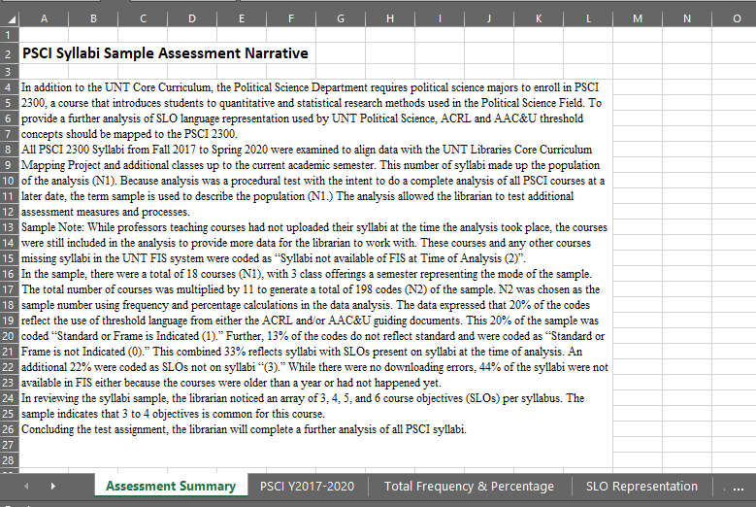
After completing the narrative, communicate the assessment narrative and complete data workbook to the department chair and faculty for their review as well as any other stake holders. Offers to work with faculty to create lessons or workshops for classes and students that address the threshold concepts.

Extended Executive Summary
An extended executive summary could also be written. This summary provides more detail than the executive summary and divided paragraphs into sections.

Sample

PSCI FA2017-SP2020 Curriculum Map Assessment Narrative
As a continuation of UNT Libraries’ Core Curriculum Map, the Political Science Librarian completed a curriculum map of PSCI non-core course offerings by analyzing student learning objectives (SLOs) language to threshold concepts from the ACRL Framework for Information Literacy in Higher Education (ACRL Framework) (2016) and the AAC&U Information Literacy Value Rubric (AAC&U Rubric) (2013). This analysis aims to identify how information literacy is taught in the PSCI curriculum. This analysis allows the librarian to scaffold and fill gaps in information literacy instruction and develop an information literacy plan for PSCI course work.
In this analysis, the term course is used to define seminars or lectures included in the registrar’s enrollment offerings (i.e. PSCI 2300). The term class is used to denote a specific section of a course (i.e. PSCI 2300.001). Student learning objectives (SLOs) are defined as concepts, goals, and outcomes that students who complete the class will gain. It is important to note that syllabi with course objectives, goals, rationale, and descriptions were not considered SLOs for this analysis as they place more emphasis on what the course will cover and not what the students are supposed to learn. The key linguistic difference between SLOs and course objectives is the degree of student agency in their learning.

Population
The librarian reviewed 396 classes (N₁) from the FA2017 to SP2020 academic semester as the population of the analysis. Core courses and courses offered in the summer were not a part of the analysis. SLOs from each class syllabus had the potential to match to any of the 11 thresholds of information literacy during the coding process. The total number of codes in the data set equals 4,356 (N₂). Syllabi were downloaded from the Faculty Information System (FIS).
However, a large majority of the classes in the population did not have syllabi available to code. Thus, the librarian included only classes with syllabi available in the analysis. This sample of 89 class syllabi (n₁) yielded a total of 979 codes (n₂). The 89 syllabi (979 codes) represent 22.47% of the total population. The relationship between the sample and the population is provided in the data analysis results.
To be consistent with the UNT Libraries’ Core Curriculum Mapping Project, the average number of SLOs per syllabi is 6, though a range of 3 to 32 SLOs is present in the population.

Methods
With the help of a graduate student assistant, the librarian coded the classes in an Excel matrix using content analysis methods. The student also assisted in downloading syllabi from FIS. The librarian contacted the registrar’s office to confirm course rotations and class sections with faculty.
The librarian reviewed the syllabi population with the guiding threshold documents to create a customized codebook prior to the content analysis methods phase. As the librarian completed the data analysis, the codebook expanded to become a process manual and codebook guide for curriculum mapping.
The content analysis method used in this project was developed during the UNT Libraries’ Core Curriculum Map and proved to still be an effective mapping method. This method assigns each threshold concept a literacy code and a numerical code of 0, 1, 2, 3, or 4 based on representation and linguistic analysis. When the SLOs on the syllabi directly or indirectly matched any of the 11 threshold concepts from the guiding documents, the class received a code 1 for that concept. If there was no match between SLOs and thresholds, the class received a code 0. Additionally, classes without SLOs, as defined above, present on syllabi received a code 3 and classes without syllabi in FIS received a code 2, with the understanding they were not available at the time of the analysis and may have been available at a different time. The methods also allowed for syllabi with FIS download errors to receive a code 4. No classes received a code 4 during the analysis.

Data Analysis Results
Because of the high frequency of code 2 in the matrix, the librarian chose to exclude code 2 (total codes: 240), code 3 (total codes: 67), and code 4 (total codes: 0) to create a sample of 89 syllabi (n₁) with SLOs available. Again, the 89 syllabi (979 codes) represent 22.48% of the total syllabi population. Within this sample, the frequency of code 0 was 527 or 12.10% of the total code population, and code 1 was 452 or 10.38% of the total code population. Receiving a code 1 is considered positive and desirable in the analysis as it indicates a match between SLO and threshold concept.
In the sample, classes positively coded the ACRL Framework threshold “Authority is Constructed and Contextual (AU)l” 98.88% of the time, making it the highest threshold taught in the PSCI curriculum. Second to this concept is “Use Information Effectively to Accomplish a Specific Purpose (UI)” from the AAC&U Rubric at 85.39% representation. ACRL Framework threshold “Information has Value (IV)” scored the third highest match with 79.76% representation. The fourth highest match was “Evaluate Information and its Sources Critically (EI)” from the AAC&U Rubric with a 60.67% representation match. Lastly, scoring just under 50% representation is ACRL Framework threshold “Research is Inquiry (RI)” with a 49.44% representation match. The six remaining thresholds that received representation matches lower than 50% ranged from about 8% to 33% representation.

Implications of Results
The difference between the threshold representations “Use Information Effectively to Accomplish a Specific Purpose” and “Research is Inquiry”, some 35.95%, first drew the librarian’s attention. To her, this indicates that the professors are communicating that course information will be applied in some manner in the class but not specifically or exclusively as a research assignment. Professors may choose to have students conduct other types of assignments, projects, or tangibles during the course. As post-undergraduate work in political science fields is not limited to academic pursuits, this is a positive finding to the librarian. This assumption is supported by the high frequency of “Evaluate Information and its Sources Critically” as it suggests that professors are communicating developing critical thinking skills through some type of assignment. Keeping this in mind, the librarian would like to see an increase in the representation of “Scholarship is a Conversation (SC”) threshold in the matrix as this concept provides students with context of how their classwork relates to scholarship and information output in the field. This threshold strengthens “Authority is Constructed and Contextual,” “Use Information Effectively to Accomplish a Specific Purpose,” and “Research is Inquiry” by authenticating the student’s scholarly and professional agency within the scope of the field.
Further, “Determine the Extent of Information Needed” and “Access the Needed Information” both received representation scores in the 20% range. Both low percentages indicate that the SLO do not convey the need to use databases and resources available in the library. Since continuing database and journal subscriptions and access is often dependent on usage data, these percentages need to rise to validate the PSCI collections in the library. Communicating that students are expected to use or learn how to use databases to complete coursework also provides initial context to course assignments during class orientation days. Such SLOs would also increase representation of “Searching as Strategic Exploration,” the lowest represented threshold, which emphasizes finding and using the best research sources for a particular research question or assignment.
Lastly, the low representation of “Access and Use Information Ethically and Legally” at 14.61% indicates that few faculty teach students how to adhere to academic honesty standards. Such a low representation—albeit one that could be presented elsewhere in the syllabus—presents problems when holding students to university academic integrity policies without teaching them how to avoid plagiarism.

Further Research and Limitations
It is important to note that the ACRL Framework for Information Literacy in Higher Education and the AAC&U Information Literacy Value Rubric are not typical guidelines for teaching faculty when developing course syllabi. Most faculty are likely to use Bloom’s Taxonomy, published in two parts in 1956 and 1964, to create student learning objectives or course outcomes. Review of the use of Bloom’s Taxonomy in PSCI SLOs could be an additional area of comparison in the map for those objectives that do not match positively to an information literacy threshold concept.
Further, the researching librarian acknowledges the narrow definition of student learning objectives in this study. The choice to exclude course objectives, goals, and descriptions was not made lightly by the librarian. Based on subject-verb construction of wording and subject-agency relationship in the sentences, course objectives tend to have wording that presents course topics covered in the course as well as ideas that the class as a whole will be exposed to. While such sentence structure can actualize group learning in a class, the librarian deliberately chose to focus on the study of the possible learning of an individual in the class because retention and persistence data is usually analyzed at the individual level.
Lastly, the librarian acknowledges that syllabi contain information about assignments outside of the SLOs, like including information about assigned readings, assignment expectations and grading, and citation methods for the field. Many professors include assignment descriptions and expectations before presenting the schedule of the class and such information would likely provide positive representation for many of the lower scoring thresholds. While this is a limitation to the study, it is important for faculty to also consider creating SLOs for their assignments and present them at the beginning of the syllabus. When assignments are presented in syllabi, they are often presented in a way that removes the learning process out of completing the assignment. In this way, assignments become benchmarks, milestones, and checkmarks to complete the course, not to learn the course content. While this is a subtle difference, it has huge implications of retaining course information after completing the course. Further assignments as learning tools provide context to assignments within the course framework and pedagogy.

Conclusion: Suggestions Based on Findings
Increasing the threshold representation can be a fairly simple process should faculty want to increase information literacy learning in their classes.
First, faculty should consider writing their objectives with bulleted lists under an introductory phrase such as “student will learn” proceeding the list. The subsequent list can then start with verbs using Bloom’s Taxonomy. This format allows for SLOs to be found quickly for parties doing syllabi analysis like the Libraries and Office of Accreditation who also preforms similar content analysis processes.
Second, faculty should consider including language that makes assignments, like research papers, part of the learning experience in the class instead of a benchmark for completing course requirements. Framing research and course assignments within the context of learning allows students to re-shape their understanding of the purpose of research and classwork as ways to engage with course content and increase knowledge retention. Likewise, processes like using library materials, accessing databases, evaluating articles, and citing sources become embedded in the learning process.
Finally, faculty might consider storing older syllabi in FIS instead of replacing syllabi with revised content. Using FIS in this way would archive class syllabi and provide a historical or legacy documentation to course and class development. Such a historical archive would provide insights into the curriculum development of the department especially when considering the preservation of syllabi of faculty who retired from the department.

The Core Curriculum Mapping Project used 6 as the average number of objectives per class.
All syllabi available in FIS were downloaded in January 2020; thus, syllabi represent a wide range of semesters up until Spring 2020 semester.
Librarians Greg Hardin, Carol Hargis, and Brea Henson received the Texas Library Association’s (TLA) Library Instruction Round Table’s (LIRT) Project of the Year Award for their work on The UNT Libraries’ Core Curriculum Map.
240 syllabi were not available in FIS and most of them were for section taught over a year ago.
Texas State Legislation mandates that faculty make syllabi available publicly and UNT’s FIS has been designated as their public archive for compliance purposes.

