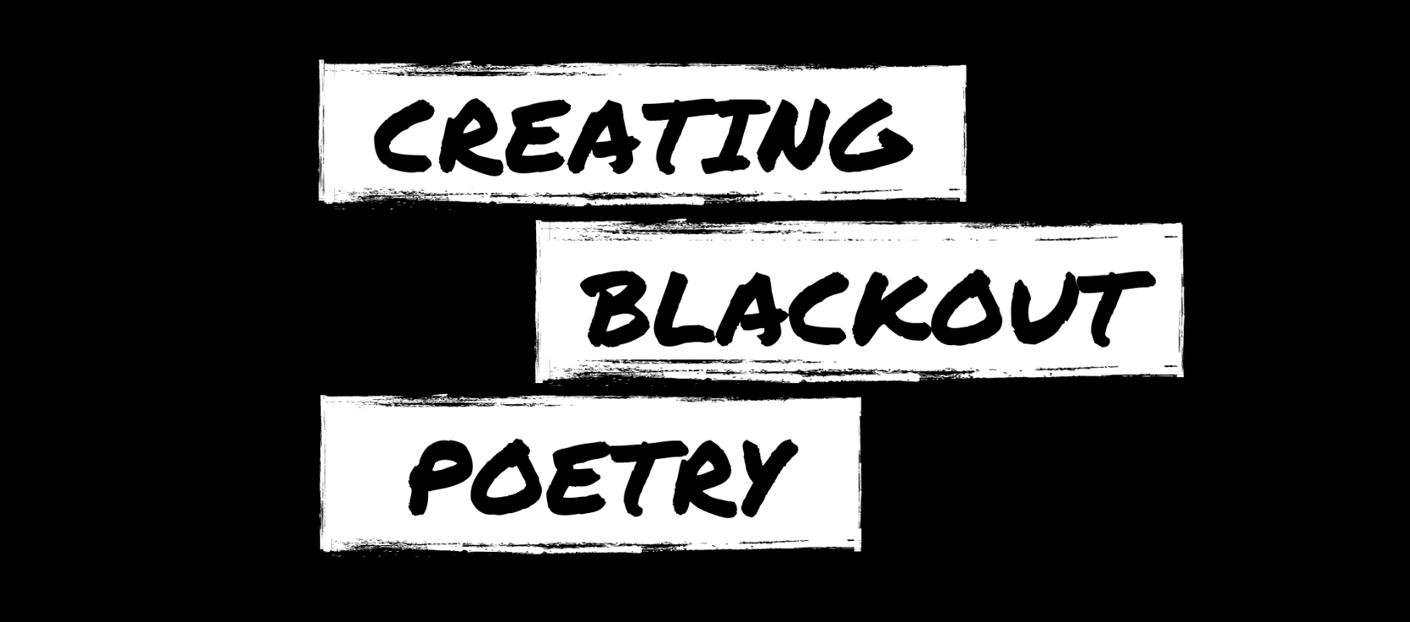

Steps:
- Gather a recycled book or newspaper page, a black writing utensil, and a pencil.

- Read through the text on the page.

- Find an anchor word that inspires you and circle or box it out with pencil.

- Continue reading and circling or boxing out words and phrases to create a poem.

- Black out all other words on the page with the black writing utensil.

- Optional: Add drawings to complement your poem.

