When evaluating information
use the S.I.F.T. Method!
(Modified from Mike Caulfield’s “SIFT: The Four Moves: https://hapgood.us/2019/06/19/sift-the-four-moves/)

Stop, Investigate, Find other coverage, Trace claim to original source
Today, we will be focusing on I and F
- STOP
“First, when you first hit a page or post and start to read it — STOP. Ask yourself whether you know the website or source of the information, and what the reputation of both the claim and the website is. If you don’t have that information, use the other moves to get a sense of what you’re looking at.”
Don’t share it until you know what it is.
- INVESTIGATE THE SOURCE (SIFT)
Who is the author? What expertise do they have? What organization(s) are they affiliated with?
  - Who is the author/creator? _________________________________________
Is this their full, real name? If not, what is their full, real name?
__________________________________________________________________
  - What expertise do they have?
That’s a big question! How do you determine someone’s “expertise”? Start by looking at their Education and Experience:
    - What is their educational background?
      - What educational degrees/credentials do they have?
In what field? _________________________________________
      - How to find this out:
        - Do they have their own website? Look for a Bio or About Us/About Me section.
(BUT! What is the downside if you only look at their website?)
__________________________________________________________________________________

        - Google them.
Look in other places! Look at other sites/sources of info.
What else can you find out about them?
Feel free to look at Wikipedia!
Yep, you read that right. BUT…remember to look at the References at the end.
__________________________________________________________________________________

__________________________________________________________________________________
    - What experience do they have? “experience” as in:
      - Work experience
        - What do they do for a living? What’s their current job/position?
        - What have they done in the past?

      - Writing experience: Are they “published”?
        - Have they published any academic articles? Y N
Look in Google Scholar (https://scholar.google.com/). List articles below.
If so, what are the articles about?
        - Have they published anything on the open web, such as blogs, websites?
(“Google” the person, see what you can find.)
  - What is the name of the group/organization that’s responsible for the content?
(This is also a good starting point if you can’t identify an author/creator.)
________________________________________________________________
    - What can you find out about the organization?
(Look for an About Us section. What can you find out there?)
BUT! What is the downside if you only look at the website?
    - What reputation does that organization have?
Google them. See what others have said about them.
Feel free to look at Wikipedia!
Yep, you read that right. BUT…remember to look at the References at the end.
    - Does it seem like this group/organization is objective and fact-based? Biased? Do they have an agenda? Mixture?

- FIND ADDITIONAL COVERAGE (SIFT)
Your focus here will be on what other reputable sources are saying about the claim/argument/position being made.
  - What claim is the author (or organization) making? What position are they taking?
Work as a group to summarize that claim/position into a question, a statement or a collection of keywords – then write it below:
  - Now enter that question, statement or keywords into Google.
What are other reputable sources saying about that claim/position? Are those sources supporting it? Refuting it?
For today, I think we’re only going to have time to look for TWO.
Additional Reputable Source #1:
________________________________________
What they’re saying: (Supporting? Refuting?)

Why do you trust this source?

Additional Reputable Source #1:
________________________________________
What they’re saying: (Supporting? Refuting?)

Why do you trust this source?

GO TO THIS BLOG: https://jbhandleyblog.com/home/autismrecovery
(Or if it’s easier https://tinyurl.com/yxc9mv7k)
Note: Just read the first paragraph or so of the blog, no need (or time ☹) to read all of it.
Scenario: You’re researching vaccine use in the United States and you come across this blog. (Assume your instructor is okay with a blog.) Can you trust the information from this blog? Using the S.I.F.T. method above, see what you can find out about the author and the information they propose.
- Briefly tell the class who JB Handley is and what you were able to find out about them. (education level, their occupation/what they do/have done for a living)
  - Where on the internet did you look for this information?
- What group(s) or organization(s) is Handley affiliated with? What are you able to find out about that group/organization?
- Is Handley “well-published”? Did you find any articles in Google Scholar?
- What reputation does Handley and the groups/organizations they’re affiliated with have?
- Finally, would you trust the information presented in this blog?

GO TO THIS PODCAST SITE: https://tinyurl.com/2p8pwdss
“What happens to event horizons when black holes collide?”
Note: Start at 2:00 (click the jump-ahead-30-sec button 4 times) to avoid the ads and just
listen to the first minute or two, no need (or time ) to listen to all of it.
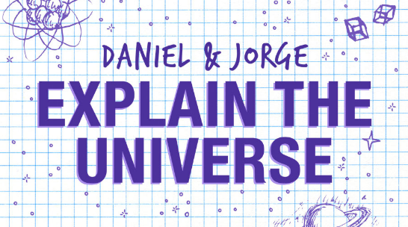
Scenario: You’re researching black holes and you come across this podcast (assume your instructor is okay with a podcast) in which the hosts claim that event horizons merge when black holes collide. It seems serious and informative but you notice the podcast logo looks…well, kinda cartoonish which makes you suspicious:
Who are “Daniel” and “Jorge”? Are they experts? Or just two guys trying to be funny?
- Briefly tell the class who Daniel and Jorge are and what you were able to find out about them. (education level, their occupation, what they do/have done for a living)
- Where on the internet did you look for this information?
- Are they “well-published”? Did you find any articles by them in Google Scholar?
- What reputation do they have? Does their blog have? Are others debunking or disagreeing with them?
- While you might not use this particular podcast exclusively to find out about black holes, would you trust information by these two people? Do you think they’re credible?
GO TO THIS YT VIDEO: https://youtu.be/B5-NtLmKUDE
(Or search for caitlin doughty embalming)
Note: Just watch the first 1:00 or so of the video, no need (or time ☹) to watch all of it.
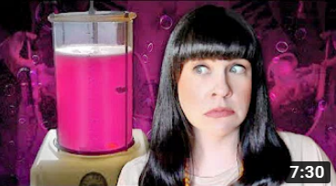
What Happens to a Body During Embalming?
Scenario: You’re researching modern funeral practices in the United States and you know
embalming is common, so you decide to learn more about it. You come across this video
(assume your instructor is okay with a video) and it seems very informative but it also seems…well, kinda funny and entertaining which makes you suspicious. Using the S.I.F.T. method above, see if you can find out it Caitlin Doughty is really an expert on this. Or is she just someone trying to be funny?
- Briefly tell the class who Caitlin Doughty is and what you were able to find out about her. (education level, her occupation/what she does/has done for a living)
- Hopefully you found her TED Talks on YouTube. Knowing she’s done TED Talks – how does that impact your view of her credibility? (First of all, what *is* a TED Talk anyway? Why is it a big deal if someone has done a TED Talk?)
- Is she “well-published”? Has she published any books? How about scholarly articles - find any in Google Scholar?
- No doubt, she’s engaging and entertaining. Did you initially suspect her expertise and credibility due to this?

