Tweet Response Simulation
Assignment Description
Twitter plays a new and complicated role in this political era. While it’s been used for some time as a messaging tool, President Trump uses it to speak directly to his followers. His tweets provide commentary, and sometimes announce policy. Consequently, the political landscape now includes responding to tweets. Whether it is the news, the White House or organizations related to or interested in the topic of a tweet, rapid response to a presidential tweet is now common practice.
In this activity, you will practice responding to a presidential tweet. You will be required to find, evaluate, and effectively use information to make a case from a particular perspective. Unlike a research paper, which aspires to be neutral or unbiased, this activity asks you to respond to a tweet from a particular perspective. The four perspectives we will take are:

1. White House Press Secretary
2. Advocacy organization
3. Right-leaning news organization
4. Left-leaning news organization
[Note: depending on the tweet chosen or the course in which this exercise is used, you might wish to have different perspectives.]

Each group must craft four (4) minutes in response to the tweet, to be presented to the class. Your presentation format will depend on your organization’s perspective. For the White House Press Secretary, you should prepare a press briefing; advocacy organization, a press conference. The news organizations will present a news story.
You are seeking to justify, explain, argue for/against, analyze, and discuss the implications of the tweet from the perspective of your organization.
The audience will be able to ask you questions at the conclusion of your presentation, so prepare both your arguments and counter-arguments. Furthermore, group order will be randomly selected (News organizations could have a broadcast before the White House Press Briefing – the order of information-sharing is not set). Therefore, be prepared to counter arguments you hear before yours and to be flexible in your argument.
The goals of this simulation are for you to gain experience finding and critically evaluating information to support or counter a specific tweet and/or policy announcement (and to consider the political and social implications of tweets). Part of the exercise is also in using that information, and thinking critically about how information is created.
Evidence - Everyone’s discussion must be grounded in research around the subject of the tweet (it does not have to be grounded in research around what actually happened in response to the tweet – in fact we’d prefer it not to). The selected tweet will have a connection to the focus of our class (e.g., global politics, black politics), and part of your discussion should address those implications. You shouldn’t make up any information. The other teams can questions your sources, so you need to be able to back them up.
Attribution - You must attribute your evidence in your discussion (i.e. According to Nielsen data…; A World Health Organization study found…). The evidence you use to support your discussion must be accurate and accessible.
Participation- Every group member must contribute research and analysis, even if the whole group will not present (though you could have several people present, it doesn’t have to just be one). Everyone will get the opportunity to speak in the plenary discussion.
Submission – In addition to your in-class participation, you will be required to submit a bibliography of the sources you used, and your group’s presentation script.

Timeline

Introduce Simulation
Simulation Introduction
Library Instruction
Students search for resources as homework.

1-2 weeks later
First 30 minutes of class – Time to meet with your group and discuss evidence you have found and the argument you plan to make

1-2 weeks later
Simulation
- 15 minutes – Groups to gather one last time to finalize their argument and prepare their “Behind the scenes” explanation
  - Group order will be randomly selected. You may respond to previous groups in your presentation.
- 4 minute group presentations (with 1-2 minutes for questions for each group)
- Discussion

Instructor Information

Introduction:
The simulation begins with a class to introduce the assignment. We discuss the idea that tweets now play a new role in politics, and the way information is created and spread and discuss what is expected of students. We then pass out the assignment description and the chosen tweet. These are the tweets chosen thus far:

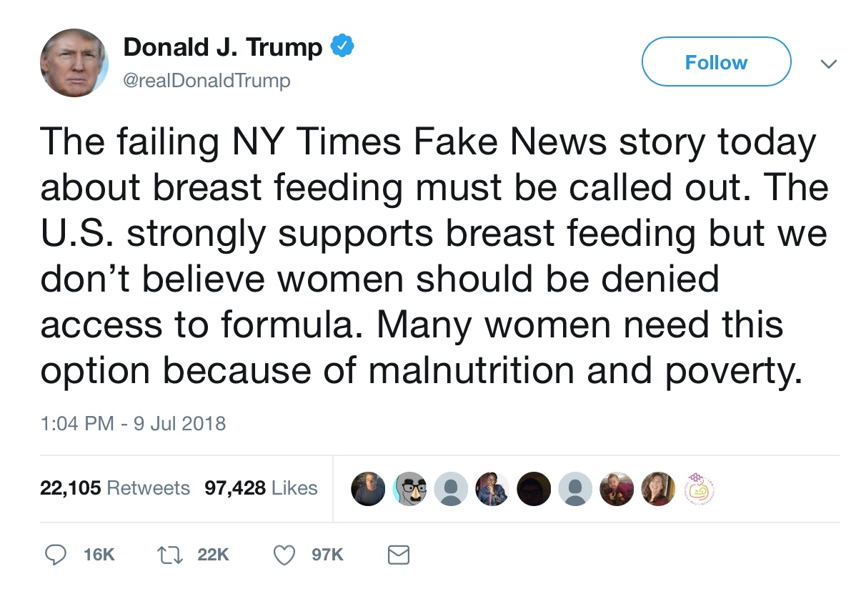
For Global Politics in the Era of Trump

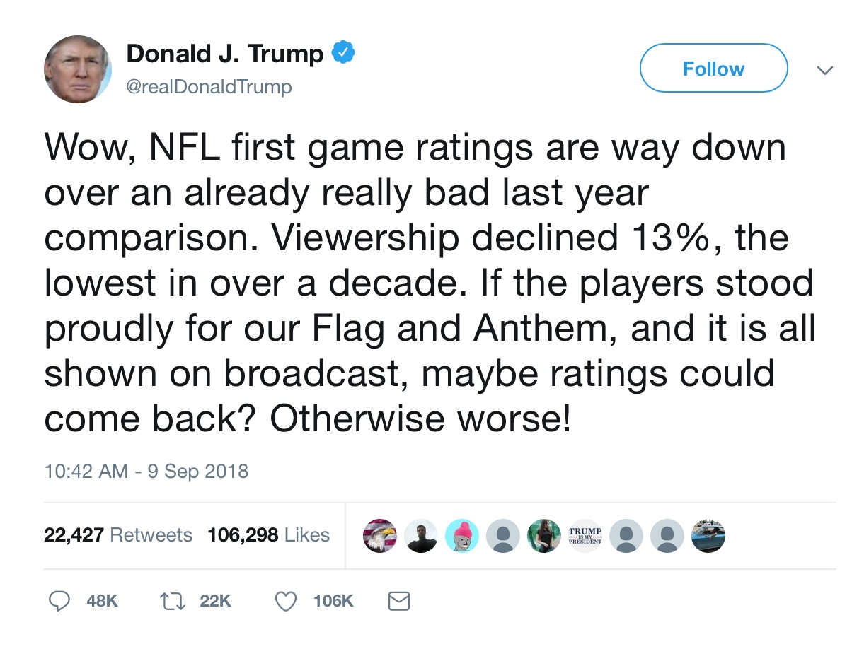
For Black Politics

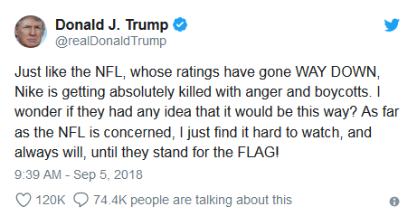
For Discovery Civics
Keep in mind that while we designed this exercise to grapple with civics and political science students about the President’s use of Twitter as a medium, this is not the only context in which a simulation would be valuable. A simulation could focus, for instance, on a different public figure (e.g., James Gunn, a movie director fired for years-old tweets) or context (e.g., a diplomatic dispute between Canada and Saudi Arabia that unfolded over Twitter).

We then form groups and assign perspectives. It is up to the instructor whether they would like to form the groups or let the students form the groups. That being said, we think it’s important to randomly assign perspectives. Students enter with their own biases and perspectives and we think it is important to get them to not simply pick a perspective they agree with, so we draw perspectives from a hat.

Once they have their perspectives, we allow time for students to discuss with their groups, to think about different angles they might take and different types of information they may need, and encouraging any students who might be frustrated with their assigned perspective.

After some time working in their groups, with the facilitators circulating to answer questions and prompt thinking, the librarian then provides brief instruction on navigating library resources for their research (while acknowledging that students are allowed to use Google for research for this assignment).

Half-way class:
Whether it is one week or two weeks after the introduction of the simulation (how much time is allotted is up to the instructor), there should be some additional class time allotted for students to connect with their groups, and to create some accountability in their research process. The facilitators are not present for this class, but the instructor can remind students that if they need assistance, they can visit the library.

Simulation:
The day of the simulation class, student will again have a little time (~15 minutes) to check in with their groups.

Then, we draw from a hat to determine presentation order.

Each group will present for ~4 minutes (a timer is used so they know when their time is up, but they are allowed to continue talking). After that, the other groups are allowed to ask questions. Anyone in the presenting group may respond to the question, not just the presenter.

After each group has presented, we have a discussion about the process. These are the suggested discussion questions, but facilitators can add or adjust based on the presentation content and questions.

Discussion Questions:
- Which group won the news cycle? Why?

- What is one tool/technique that another team used that you found to be effective?

- Based on your experience with the simulation, what chain of events does a tweet set in motion?

- How did this exercise effect your relationship to information? Was the information you needed objective and easy to find? How did you decide what information was accurate and what information wasn’t? How did you decide what was true and what was reliable? How did you approach “spin” – using reliable information, but perhaps not in the way that it was intended?

- In this simulation, you played the role of authoritative content creators. Please discuss the idea that authority is constructed and contextual.

- If you had to write a guideline for global leaders using twitter, what would you advise?

- For those who were in the media role, how do you think the media should cover tweets? How does this differ from how they cover them currently?

- How does the rapid news cycle affect your responses about how the president’s tweets function. i.e., does the fact that even something very consequential can get crowded out by other news stories very quickly affect their responses on the effectiveness/disruptiveness of tweets as a communication tool?

- How did the genre of your presentation (e.g., press briefing, news report) influence how you selected and presented information? Do you think different forms of presentation change how you use information?

- What did you learn by doing this simulation?

In addition to the discussion questions, we also ask students to fill out a feedback form, to assess their perceptions of the simulation, and get feedback to adjust and improve the activity.

We have used this simulation in the following courses:
Global Politics in the Age of Trump – Summer 2018
Discovery Civics (2 sections) – Fall 2018
Black Politics – Fall 2018

