The Owen Graduate School of Management, Vanderbilt University
MAcc – Masters of Accountancy, Valuation
Immersion Week: Business Research for Valuation Professionals

Assignment II: Database Exploration & Analysis for Valuation Professionals

Sample
Jane Doe
MAcc Immersion Week
Assignment II: Exploration & Analysis of Databases for Valuation Professionals
October 14, 2016
Company: Starbucks (Ticker: SBUX)
NAICS industry code: 7225(15)

- Fundamentals – Earnings/EPS Estimates

Brief Analysis
After getting over the Bloomberg learning curve, the Earnings & EPS Estimate was easy to find under company XXXX. I thought the XXXXX in CapIQ was XXXXX compared with the other resources, but I also noticed XXXX. It was XXXX to locate this data on Zacks, but it is clear that that resources is XXXX, and it XXXX. If I were focused on EPS XXX (e.g. growth, estimates, etc), I would choose XXX database. If I had to choose just one resource for finding this data again, my choice would be XXXX because XXXX.

Screenshots

Refinitiv Workspace
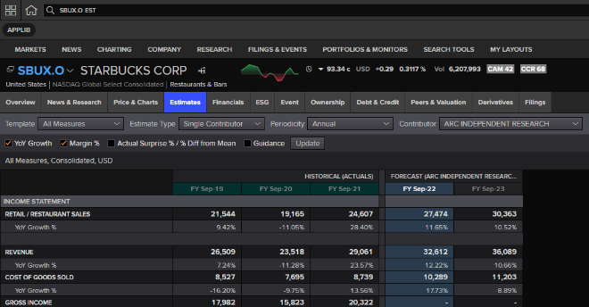

CapitalIQ 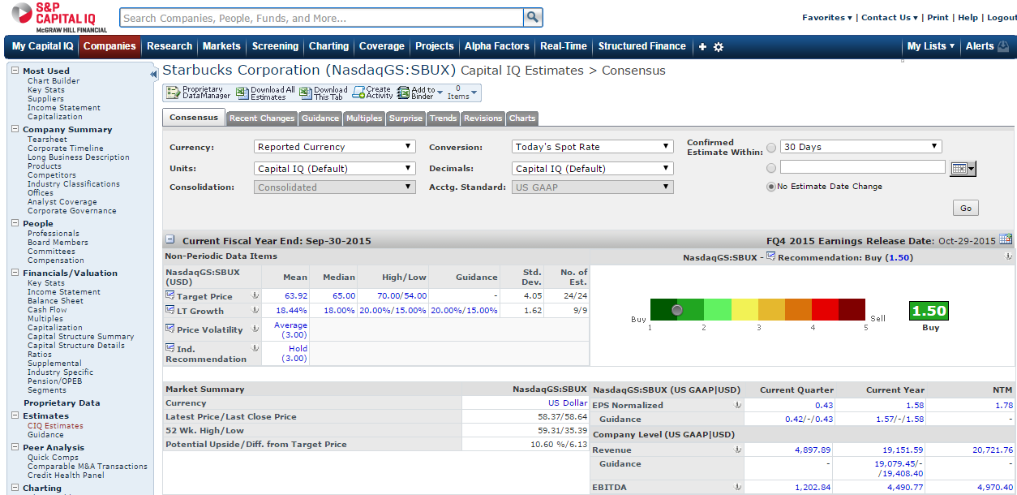

Zacks
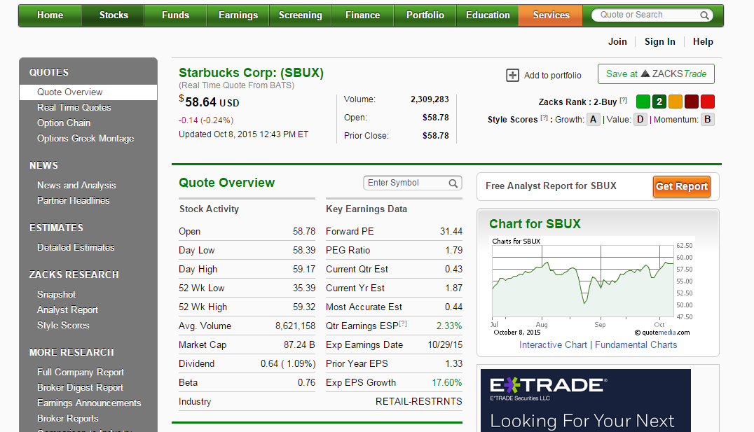

Bloomberg
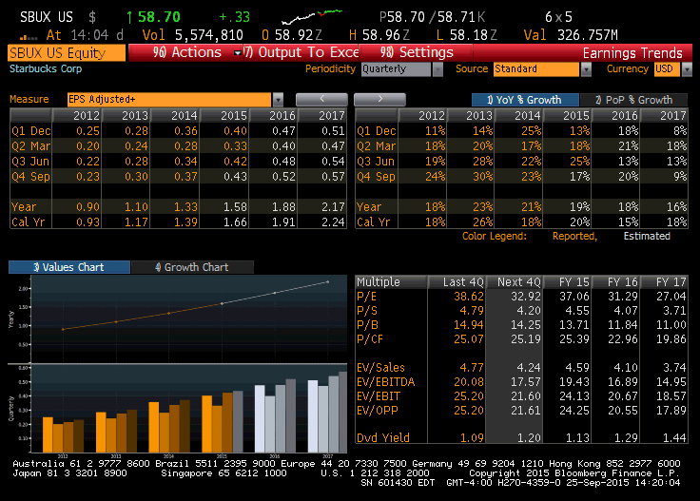

- Financials - Current & Historical Balance Sheets (quarterly)
Same format as above: 1 paragraph analysis or resources utilized followed by screenshots of each data source.

- Corporate Events: Corporate Calendar and/or Conference Call transcript
Same format as above: 1 paragraph analysis or resources utilized followed by screenshots of each data source.

- SEC Filings: CEO Compensation
Same format as above: 1 paragraph analysis or resources utilized followed by screenshots of each data source.

- Industry Analysis
Same format as above: 1 paragraph analysis or resources utilized followed by screenshots of each data source.

- Comparables
Same format as above: 1 paragraph analysis or resources utilized followed by screenshots of each data source.

- Data Visualization using Company Financial Data
This section should include the data visualization along with an explanation of why you chose the particular data set, and how data viz added (or didn’t!) to your understanding of that company and its performance in a way that traditional analysis did not.

- Industry Websites and Associations
While using First Research, I came across the XXX association, which advocates for companies in the XXX industry by providing the following services and information: xxxx, xxxx, and xxxx. I found the xxx data they provided helpful because xxxx.

- Analysis of the company within the industry context.
This section can be up to one page, focused on the information you discovered during this assignment, and should be written by you in the role of a company and industry analyst.

- Buy/Sell/Hold recommendation for your company stock.
Based on the information gathered during this assignment, and your analysis of the company within its industry context, provide a Buy, Sell or Hold recommendation.

