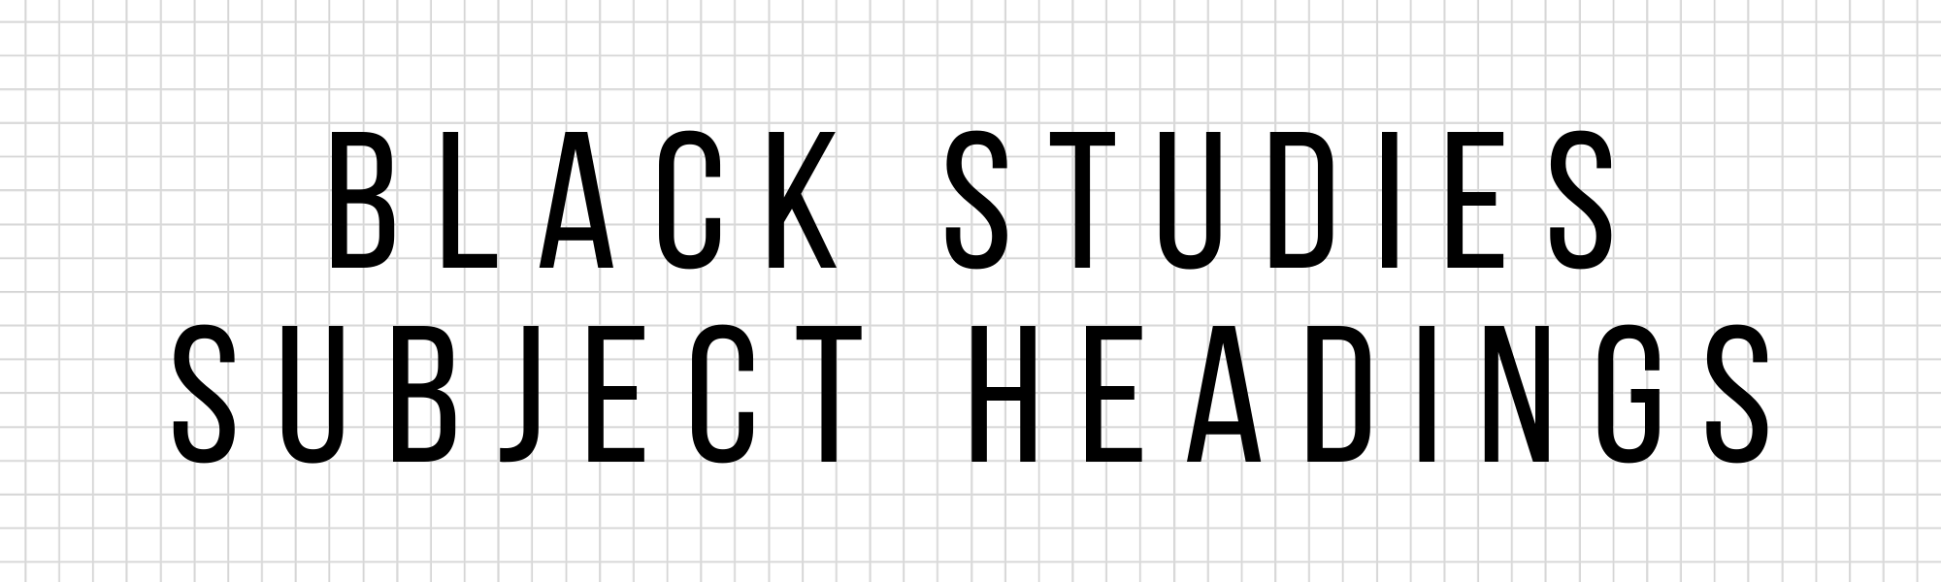

| sFind examples of recently added or updated Library of Congress Subject Headings below, former terms, non-standardized terms and example authorized terms and subdivisions.dfs |
| --- |

| **Authorized Term** | **Former or Non-Standardized Variant Terms** | **Examples** |
| --- | --- | --- |
| **African Americans** | Black Americans, Colored people (United States) | African Americans–Biography  African Americans–Social conditions–History |
| **Black people** | Black persons, Blacks, Negroes | Black people–Cuba–Ethnic identity |
| **Black towns** | African American towns, All-Black towns, Freemen's cities, Freemen's towns, Freedom colonies, Independence colonies | Black towns–North Carolina--Princeville |
| **Black wall streets** | Black wall street neighborhoods, Black wall street districts | Black wall streets–History |
| **Colorism** | Shadeism, Colourism, Shadism, Skin-tone Bias, Bias, Skin-tone | Colorism–United States |
| **Enslaved persons** | Slaves | Enslaved persons–Louisiana– History–18th century |
| **Great Migration, ca. 1914-ca. 1970** | Great Black Migration, ca. 1914-ca.1970 | Great Migration, ca. 1914-ca. 1970–Sources |
| **Historically Black colleges and universities** | HBCUs (Historically Black colleges and universities) | Historically Black colleges and universities–Juvenile literature |
| **Night riding (Racial violence)** | Ku kluxing (Night riding), Kukluxing (Night riding), Nightriding (Racial violence), Paterolling, Patter-rolling, Patterolling, Whitecapping (Night riding) | Night riding (Racial violence)--Arkansas |
| **Racism against Black people** | Anti-Black racism, Antiblack racism, Racism against Blacks | Racism against Black people–United States |
| **Slave markets** | Slave depots, Slave marts | Slave markets–Louisiana–New Orleans |
| **Sundown towns** | Gray towns, Sundown cities, Sundown communities, Sundown neighborhoods, Sunset towns | Sundown towns–Fiction |
| **Transatlantic slave trade** | Atlantic slave trade, Trans-Atlantic slave trade | Transatlantic slave trade–History |
| **Tulsa Race Massacre, Tulsa, Okla., 1921** | Tulsa Massacre, Tulsa, Okla., 1921, Tulsa Race Riot, Tulsa, Okla., 1921 | Tulsa Race Massacre, Tulsa, Okla., 1921–Juvenile literature |

