Lesson Plan
FYE 100C 03: First Year Experience

Faculty Request:
“I am leading one of the business-focused FYE sections this fall. I was hoping to arrange to have a librarian visit a large lecture class on Wednesday 10/2 at 12:00 to give a short presentation on how to conduct library research. In particular, our class will have a semester-long social entrepreneurship project for the students to develop a business idea to address a campus issue. Our four breakout sections will be focusing on sustainability, student success, wellness, and diversity & inclusion. Our goal after the library session is for them to be able to research what is happening on other college campuses with regard to these issues – I’m imagining more of a focus on general media than peer-reviewed literature. Is this something you would be able to help with?”

Learner and Context Analysis

Learner
Audience: First Year Experience students
Class Size: 150 students. Majority has declared major in business (management and marketing); 33 are exploratory and 10 has combined major.
Project: social entrepreneurship project for the students to develop a business idea to address a campus issue.
Class structure: 3 50-min sessions on Monday, Wednesday and Friday each week focusing on a project step. Friday is for breakout sessions, and students are split by their areas and do hands-on research led by a professor.
Research phase: students haven’t started their research. They will start the second segment of the project – due diligence in this week and ease to the third segment of stakeholder theory in the next week.

Context
Space: Lecture Hall - Schmucker Link 151
Time: Wednesday, October 2nd 2019 12:00-12:50PM
Technology: RamCast, projector, D2L, microphone, students use cell phones to participate in class polls. Bring laptop for the instruction.
Shared Responsibility: professor will do a poll assessment for the library session with suggested questions from the librarian.

Library Instruction Design

- Focused ACRL Framework Concept: Information has value
- Learning Goals:
Overall - Students can understand information has value and extends it to understand there are different kinds of valuable voices on specific issues and these voices may be underrepresented or systematically marginalized due to established information publication and dissemination mechanism. They can respond with an effort to seek different opinions in their research and contribute their own.

Affective Domain - students will feel confident and prepared for their research; demonstrating mental flexibility and creativity in information searching with intentional analysis of information stakeholders and thinking about marginalized voices. Students will value the skills and time needed to produce knowledge and put persistent and diligent effort in research. They will recognize themselves as information contributors and believe they can leverage the value of information to effect changes on our campuses and our community.

- Learning Components:
- Various information stakeholders and their specific ways of publishing and disseminating information.
- When to use library and when to use Google.
- How to design search terms
- Library databases for campus issues/programs research.
- Effective Google search for campus programs (advanced domain search)
- Research processes
- Researchers’ attitudes and values.

- Instructional Materials:
- PPT slides
- LibGuide (business)
- Online databases demonstration

- Active Learning Activity

Group role play – Getting your voice heard

Roles:
Professor, Administrator, Student, Organization Member

Descriptions:
You are a professor who has studied student success issue for more than 20 years and you have developed your own theories and knowledge on this issue. How can you get your opinion known to others? If people want to find your opinion, where should they look for?

You are the Director of the Diversity and Inclusion Office at a University. You are responsible for developing university-level diversity strategies and programs. You want to share successful practices and approaches of your office. How can you get your experience shared? If people want to find the information from you, where should they look for?

You are a student at a University. You have concerns about the recycling and waste reduction practices on campus. You don’t think the current practice is sustainable and you believe as a student you have a great role to play to build a sustainable practice for your university. You want the voices from students being heard. How can you make it happen? If people want to find opinions from students, where should they look for?

You are a member of the National Association of College & University Food Services and serve on the Nutrition Awards committee, which will select Most Innovative Wellness & Nutrition Program from your member institution each year. Your committee wants to highlight the award winners, where do you post the information? If people want to find the award-winning wellness programs, where should they look for?

Engaged Conversations:

Professor:
How can you get your opinion known to others, professors?
Books, articles, social media (Facebook, twitter feeds, etc.), TV programs, etc.
Does the information displayed in books and twitter feeds have equal value?
Can you get the scholar’s books and articles with Google search and access it for free?

Administrators:
How can you get your experience shared, administrators?
University’s website, magazines, conferences, presentations
It is more likely for people to find your shared experience online or more likely in a library?

Students:
How can you get your voice heard, students?
Surveys, magazine articles, etc.
Is your voice easier or harder to be found than the professor’s voice or administrator’s?
Why?

Association Members:
Where do you post the information of the award winners?
Websites, social media (Facebook, twitter, etc.), etc.
what other efforts you can probably make to make the award-winning practices noticeable?
writing reports. sharing best practices, organizing conferences to grant the award, etc.

Do you think the winner would announce the winning of the award through their own publication channels?
Is it more likely that you can find the information online or is it more likely in library?

- Demonstration

Library Database Search
Academic Search Ultimate: multidisciplinary database, comprehensive, including both scholarly journals, trade publication, magazines, newspaper
Campus sustainability -> publication data 2014-2019 -> source type academic journals-> magazines,
International journal of sustainability in higher education
PDF full-text vs. Check availability
Magazines (16)

US Major Dailies. – a newspaper database, which including New York Times, Washington Post, Wall Street Journal.

Campus sustainability –> publication date 2010-2019-> subject (colleges and universities)

Google Search:
Regular – campus sustainability
Adding important keyword -> campus sustainability award
Advanced search domain .edu -> find more individual university examples.
Use .org -> to find associations and explore their website

- Class Timeline:
5” logistics
Student group role play activities 15”
5 mins- students’ brainstorming
10 mins – engaged conversation
What is available in the library and what is not? 5”
Keyword design 5”
Library database search
Academic search ultimate 5”
US Major Dailies 5”
Google Search 5”
Re-cap with research process and final take-aways-> research process 5”

Library Session Assessment
Students will use their phone to take a short survey. The assessment questions include:
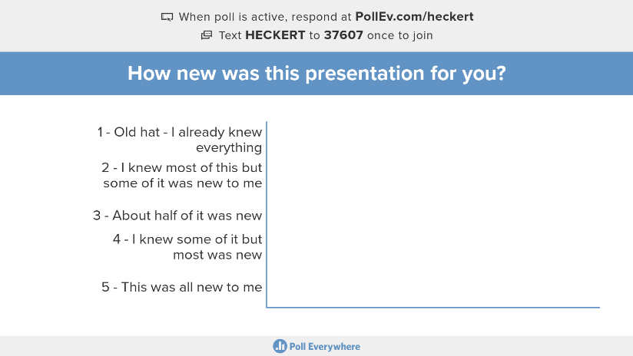

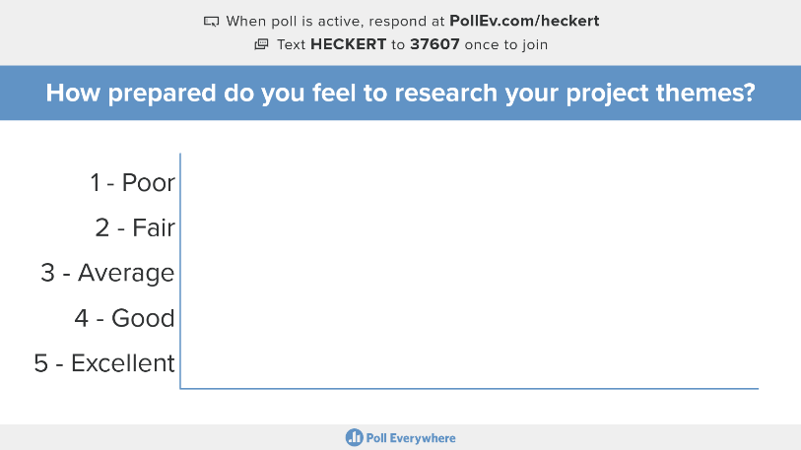

What is your most important take-away for this session?
How this session extends your current understanding of “information has value?”
How would you improve this session?

