Pin the Source on the Spectrum OR Fake News exists on a Continuum

This activity was piloted at a teach-in called “Don’t Take the Clickbait: Practical Ways to Recognize and Fight Fake News” that took place on February 24, 2017 as part of a week of “Days of Action and Dialogue” at Purchase College, SUNY. The workshop was lead by 2 librarians and 2 journalism faculty who provided historical context. It was open to everyone on campus and was very well attended for a one-shot, drop-in workshop. The “teach-in” aspect emphasized concrete actions that one can take to fight the spread of fake news. But the “Pin the Source on the Spectrum” activity can be incorporated in any class, traditional library instruction session, or put online (though participants liked the tactile aspect of sticking something on the board). Responses & reflections can be done as an in-person discussion, as we did, or via an online discussion forum, in-class free-write, or written homework assignment. It takes at least 15-20 minutes but could take longer, as desired.

To address political bias vs. nonfactual news stories, and to convey the idea that “fake news” exists on a continuum, we did a pin-the-tail-on-the-donkey assignment with a blank version of Vanessa Otero’s media bias chart: https://68.media.tumblr.com/fa9f0c2ddba0f219935c5d8e8973d28b/tumblr_oi5ocbTvJD1rbam90o1_1280.jpg

When this chart first appeared on Twitter in December 2016, it was both praised and criticized. (A quick Google search for “fake news chart” will reveal a spectrum of responses—many of which are from the news sources Otero labeled as “clickbait.”

For newer versions, do a google images search for “Vanessa Otero infographic” or go to her blog: More versions of the chart can be found here and are creative commons licensed: http://www.allgeneralizationsarefalse.com/

This chart is a useful tool for showing the nuances between “fake,” biased and inflammatory news sources. This discussion fits in very nicely with the ACRL Threshold Concept: “Authority is constructed and contextual.” The concept of a source being on a spectrum of “complex vs. clickbait” added an additional layer of complexity for students who were used to focusing on binaries: liberal vs. conservative or “trustworthy vs. fake.”

Here’s what to do:

- Hand out news media organization logos with sticky tape on the back to each person in the class (you could also use magnets or pins).
- Have the participants look up the news organization online to learn more about it—they can go to the source’s website or look up what others have to say about it. Is this media source on the left or right? Is it sensationalist/clickbait or analytical/in-depth reporting? Is it mainstream or fringe/conspiracy theory? You may need to give students longer to research this than you expect.
- After researching the news organization, participants place the logo where they think it belongs on a blank version of Vanessa Otero’s chart. We drew a simplified chart on large poster paper for one session, and projected a blank version provided by Otero at another session. You could also draw it on a white board.
- After participants place news sources on the chart, the instructors show Vanessa Otero’s original version for comparison. Do participants agree or disagree with her version? Does anyone now want to change their placement of a particular news organization? A robust discussion can ensue, taking up as much time as you want. You can also split a class into two groups and have students compare the placement of the news sources on each chart.
Here’s some prompts to further discussion:

  - Why did you place your source where you did? What factors in your research influenced your choice?
  - Where do you think a scholarly or peer-reviewed journal might fit on this continuum?

  - This chart symmetrically balances left and right. Otero chose an equal number of examples on each side of the political spectrum. Do you think fake news occurs in equal amounts on each side? Why or why not?

  - Does this change how you think about your favorite news sources? In the future how will you change how you’re getting your news?

  - Why do you think some news media sources trend towards sensationalism/ clickbait? What are the economic incentives?

Ways to Assess:

The final chart itself provides a nice snapshot assessment of the class. You visually can tell if students have adequately researched their source or if they’ve grasped the concept of a “continuum” (i.e. if someone puts the Wall Street Journal under far left conspiracy theories, you know they didn’t really do the research!). For example, we noticed that many participants stuck their logos closer to the middle and were hesitant to use the “fringe” or “utter garbage” corners. This triggered us to re-emphasize the concept that news media are not only “liberal vs. conservative” or “trustworthy vs. untrustworthy,” but that the content can also be judged as “sensational vs. analytical.” Requiring brief written reflections on why students chose to place their source in a particular quadrant, and how they researched it, can also serve as an easy assessment.

See Otero’s charts on the next page…

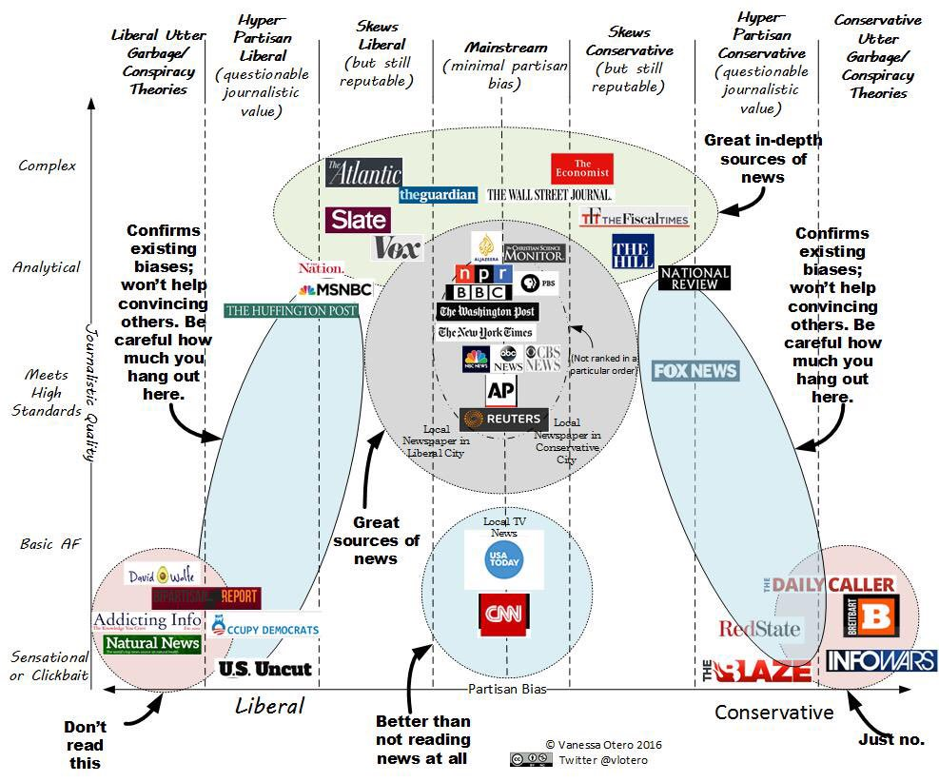
The original.
https://twitter.com/vlotero/status/809098741647077376
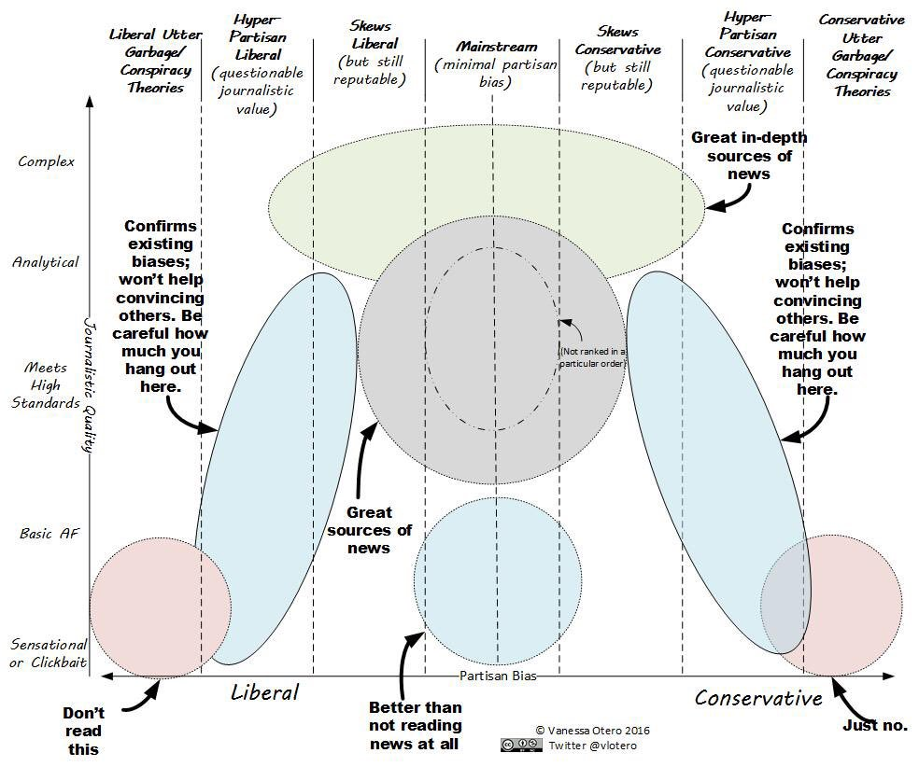

https://pbs.twimg.com/media/CzroiA8UkAAs3Zt.jpg (Otero put this blank version in a reply to her original tweet)

The updated version from Fall 2017. The Y axis has more degrees of complexity, additional media sources, and eliminates the sassy slang term “Basic AF” which is broken down into “opinion sources” and “factually incorrect”
Find this and other versions on Otero’s blog: http://www.allgeneralizationsarefalse.com/

