Data vs. Information vs. Knowledge
This is a good way to get students thinking about the conceptual differences between data, information and knowledge – which is an important first step to understanding how data, information and knowledge are created, disseminated and consumed.
This could be used in a F2F classroom setting, or set-up online as a course Discussion. Students could conduct this individually, work in pairs or groups or as a whole-class discussion.

- Watch this brief video: “Data-Information-Knowledge in 3 minutes or less” [KnowledgeMT]
https://youtu.be/sIjSY05JE9Q
- Study this image:
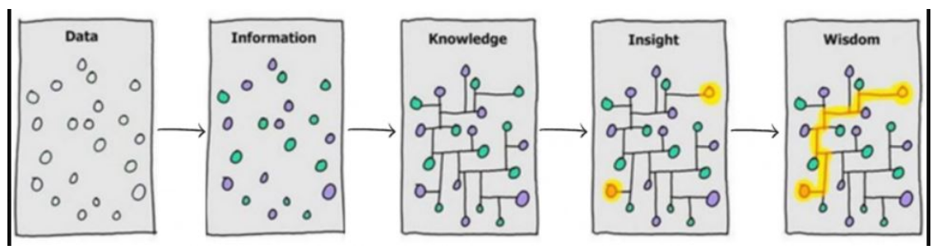
Image credit: https://sfadigital.blog.gov.uk/wp-content/uploads/sites/134/2020/08/Data-Info-Knowledge-Insight-Wisdom-768x509.png
- Consider the following questions.
  - In what way is each panel different from the one before it?
  - For each panel, answer this question: Why do you think the artist used that image to represent the panel's label? (So you'll answer this question a total of 5 times.)

